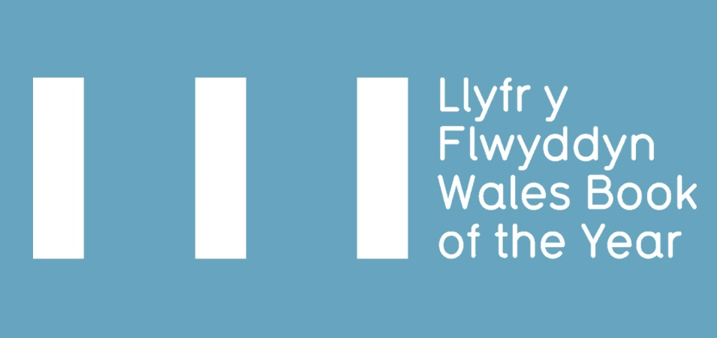

WALES BOOK OF THE YEAR AWARD 2026 – SUBMISSION PACK

- ELIGIBILITY CRITERIA
- TERMS & CONDITIONS
- ENTRY FORM 2026

Deadline for submissions: Monday 24 November 2025*
* If you foresee any issues with submitting a book by the deadline,
please contact us before 24 November 2025 to discuss.

The Wales Book of the Year Award is an annual prize celebrating outstanding literary works from Wales across many genres and in both English and Welsh.

There are four categories in each language – Poetry, Fiction, Creative Non-fiction and Children & Young People, with one of the four category winners announced as the Overall Winner, and claiming the title Wales Book of the Year. There are twelve awards in total with a collective prize fund of £14,000. In both Welsh and English there are four category winners, one independent People’s Choice winner and one overall winner.
The Wales Book of the Year Awards play an essential part in Literature Wales’ programme of activity and contributes to its strategic aim of celebrating and representing Wales’ writers, its heritage and rich literary culture. The prize offers an invaluable platform to both emerging and established writers.
The shortlist, which will comprise of three books in each category, will be announced in the spring, with the winners of Wales Book of the Year 2026 announced during a live ceremony in the summer.

ELIGIBILITY CRITERIA
Please read and familiarise yourself with the eligibility criteria for Wales Book of the Year before making an application.

NECESSARY:
- Must be published for the first time (in either Welsh or English) in the calendar year preceding the award (1 January – 31 December 2025). This must be reflected by the year printed on the book’s inside cover – in exceptional circumstances (for example, where a printing error has been made), you must send an explanation of any discrepancies in your submission to Literature Wales.
- The author(s) must have been alive on the date the book was published.
- The volume as a whole must create a new and distinct literary work and be comprised of work which has not been previously published in individually authored collections (collections containing some previously published work - for example, where individual poems have been published in magazines - will not be excluded.)
- Be a work of poetry, fiction, or creative non-fiction (see note below), OR intended for children & young people.
- Must be in print from the date the shortlist is released until the winners are announced at the award ceremony.
- Work presented to the Poetry, Fiction, or Creative Non-fiction categories must be intended for an adult readership.
- Be submitted to one category only.
- Work published bilingually can only be submitted for consideration in one language - the language in which the work was originally written.

Plus at least one of the following:
The submitted title must be connected to Wales in one of the following ways. Please note at least one of below numbered criteria in the “Connection to Wales” column when completing the submission form.
If the book is by multiple writers, each writer must meet one of the below criteria (or the work as a whole must meet criteria 1 or 4).
- Be written in the Welsh language.
- Be written in English by a Welsh-born writer, or someone who was schooled in Wales.
- Be written in English by a writer who is currently resident in Wales.
- Be of clear relevance to Wales and Welsh culture (see definition below).
If you submit a book under this condition (4) only, a short supporting statement must be submitted with the application form, clearly explaining the case for relevance (maximum 250 words).

*Definition of works which are of clear relevance to Wales and Welsh culture
Titles which discuss and/or add to themes which have a tradition of discourse in Welsh literary fields can, on occasion, be determined eligible for consideration despite the writer having no linguistic, residential, or adolescent links with Wales.
The following are not eligible for consideration:
- Individual work published within anthologies of multiple writers, or anthologies of multiple writers where the collection as a whole does not create a distinct literary work, or collections primarily consisting of previously published work.
- Work that is written or co-written by a ghostwriter.
- Work that is written, co-written, or edited using Large Language Model (LLM) AI tools.
- Work that is mainly composed of interviews or quotes.
- Translations and adaptations.
- Scripts, screenplays, and picture books without a strong narrative.

Decisions on all eligibility issues will be at the discretion of Literature Wales.

THE CATEGORIES ARE DEFINED AS:
- Poetry
A collection of new work by a single or multiple authors, intended for adult readership.
- Fiction
A new work by a single or multiple authors which is intended for adult readership. We welcome all fiction genres.
- Children & Young People
A new work by a single or multiple authors which primarily consists of literary rather than pictorial content, intended for children and young people. Fiction, Poetry and literary non-fiction are all eligible and must meet the criteria detailed in a, b & d, except for readership age.

- Creative non-fiction
We define creative non-fiction as a non-fictional narrative where the creativity of writing and author voice is central to the nature of the work. Types of literature which could fall under such criterion include, but is not limited to, memoirs, biographies, social history, or travel writing. Types of literature that do not usually fall under such criterion include gift books, coffee table books, reference books, self-help books, textbooks, art and photography books, and recipe books.

Work that is primarily academic or factual is unlikely to be considered for this category unless a strong narrative and creative component can be demonstrated. If this is not evident from the title and blurb, you must provide a short supporting statement clearly explaining the case for relevance (maximum 250 words).

Decisions on all eligibility issues will be at the discretion of Literature Wales. Decisions will be final and confirmed after the closing date.
If you are in any doubt about the eligibility of a book for Wales Book of the Year, please contact Literature Wales: LLYF-WBOTY@literaturewales.org

TERMS AND CONDITIONS
To submit your books, please send one physical copy and a pdf copy* of each title to the below addresses by Monday 24 November 2025:

Physical copy:
Wales Book of the Year,
Tŷ Newydd Writing Centre,
Llanystumdwy,
Cricieth
LL52 0LW

Please note, we may seek up to 6 additional hard copies of the book from you to assist with the judging process or for marketing purposes.

PDF:
LLYF-WBOTY@literaturewales.org

*To reduce the environmental impact of the award we are asking you to submit one physical copy and a pdf of each book. If the file is too large to attach in an email, please send via WeTransfer, OneDrive, or another file sharing method.

Additionally, please also attach a completed copy of this form along with the following items for each book submitted:
- a hi-res picture of the book cover (including any relevant credits)
- a hi-res picture of the author (including any relevant credits)
- a short description/blurb of the book
- a short biography of the author and contact details (email)
- the Advance Information Sheet (AI/AIS) for the book, if available

Please note: Literature Wales will confirm submission of titles only when all of the above items have been received.

Aside from the physical copy of the book, the above items must all be sent digitally – we will not accept printed forms or blurbs/biographies in place of digital versions.

Unfortunately, Literature Wales is not able to immediately respond to submissions. Please be patient while we review the items and information you have provided.

- Images must be sent as PNG or JPEG files. Text must be sent as .docx or .odt files (.pages files cannot be accepted). Digital copies of books must be PDFs (.epub files cannot be accepted). Literature Wales will let you know if a file has not been received correctly, but it is ultimately the publisher’s responsibility to ensure that all files are sent in the correct format.

- It is the publisher’s responsibility to secure the agreement of authors to submit books and information to the Wales Book of the Year Award.

- Any physical copies submitted by publishers will be used for the purposes of judging, marketing, and administrating the award. It is not possible to return any books.
- It is the publisher’s responsibility to indicate to which category each book is submitted. If the judges would like to consider the book for a different category, Literature Wales will inform the publisher/author.

- In the event that a book with multiple writers, for example an anthology, is shortlisted or wins an award, Literature Wales will credit each of the writers who have contributed to the book as the author (and not only the editor or editors). Publishers should send biographies of all of the writers when submitting to Book of the Year for us to process your submission.

- It is the publisher's responsibility to indicate how any cash prizes and / or trophies should be split in the event of a book written by multiple writers winning any of the categories or overall awards.

- Shortlisted authors are expected to attend the Wales Book of the Year Award Ceremony, and as a condition of entry, publishers agree to support writers to do so. Plans for the ceremony will be announced in the new year.

- As a condition of entry, publishers agree to collaborate with Literature Wales and its partners to promote Wales Book of the Year. Publishers should use the award’s branding and the assets provided by Literature Wales in the event that any of their titles are shortlisted for the award.

- Shortlisted authors are expected to collaborate with the press following relevant announcements, including being available for radio, television and print interviews. Publishers should ensure writers are aware of this.
- Shortlisted writers and winners will be required to collaborate with Literature Wales to promote the Award, including – but not limited to – creating promotional videos about their work (click here to see examples from previous years).
- Judges may consider non-submitted books, provided they comply with the eligibility criteria. Literature Wales will contact the publisher to request further books and information in this case.

2026 ENTRY FORM

Publisher

Contact Name
Email address
Phone number

English-language books
Title | ISBN | Author | Date of publication | Category | Connection to Wales*

Welsh-language books
Title | ISBN | Author Name | Date of publication | Category | Connection to Wales*
 |  |  |  |  | 1
 |  |  |  |  | 1
 |  |  |  |  | 1
 |  |  |  |  | 1
 |  |  |  |  | 1
 |  |  |  |  | 1

*Please see the list of eligibility criteria on page 3 and note the number (1-4) that corresponds to at least one of the criteria that meets this requirement.

I confirm that:
- the above writer(s) have agreed to the submission and sharing relevant information with Literature Wales | Wales Book of the Year Awards.
- the above title(s) comply with the Wales Book of the Year Eligibility Criteria, and that I have read and agree with the Terms & Conditions.
- the publisher agrees that Literature Wales may use the promotional material submitted (illustrations on book covers, book blurbs and author biographies and pictures) for the purposes of promoting the Wales Books of the Year Awards and that any required credits have been noted in the application.
- the publisher agrees to support Literature Wales with marketing the awards and any books they submit to the award, that reach the shortlist or win any awards.
- the publisher agrees to use the award’s branding and the assets provided by Literature Wales, and to publicise any events or broadcasts shortlisted and winning authors take part in to promote their book(s).
- the publisher agrees to send Literature Wales up to 6 additional physical copies of the books to support the judging or marketing process if requested.
- the publisher confirms that the work has not been written, co-written, or edited using Large Language Model (LLM) AI tools.

Name:
Position:
Signed:
Date:

