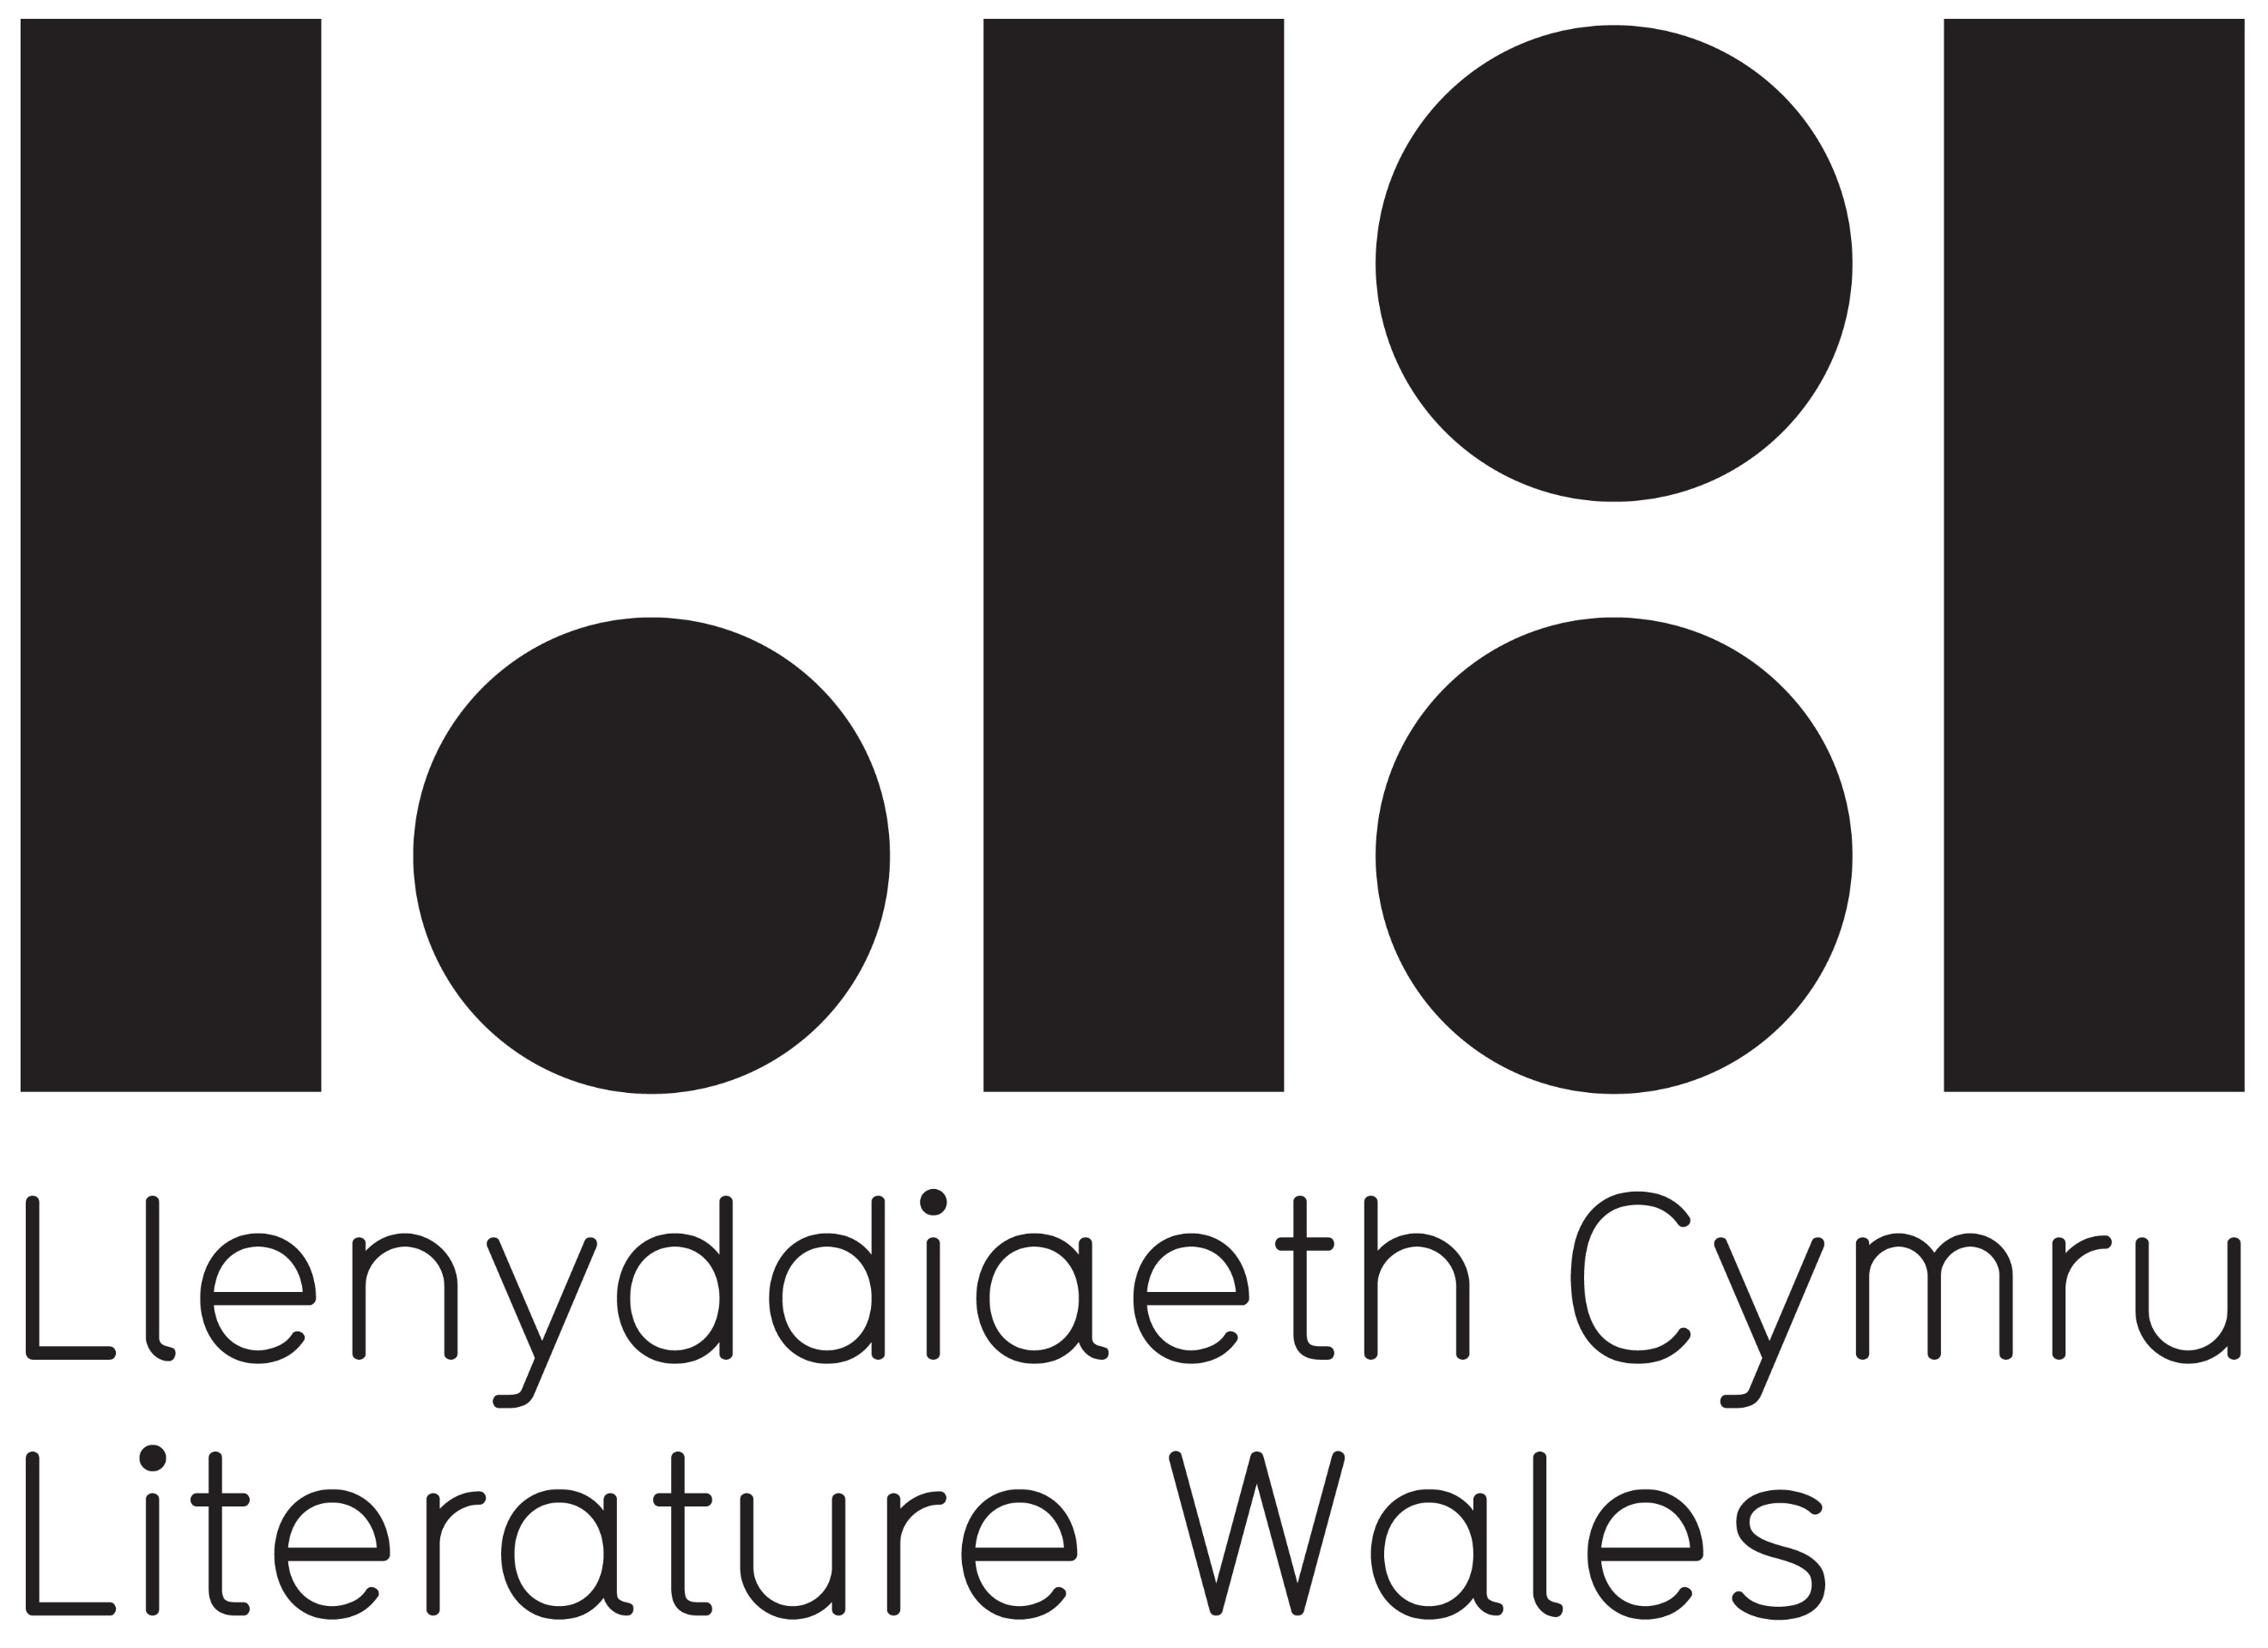
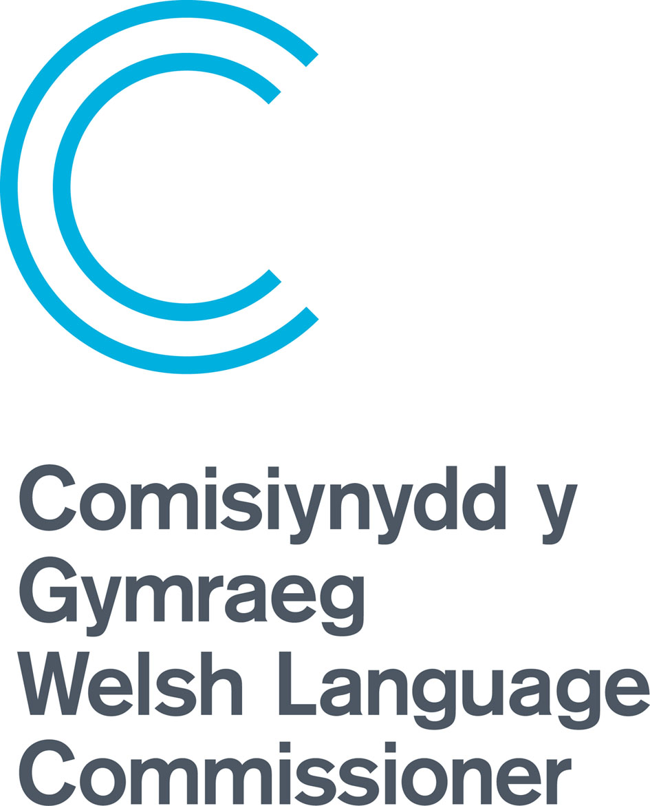

Llenyddiaeth Cymru | Literature Wales
WELSH LANGUAGE DEVELOPMENT PLAN

Prepared with the assistance of the Welsh Language Commissioner’s Hybu Team
The Plan received the ‘Cynnig Cymraeg’ approval from the Office of the Welsh Language Commissioner on 13 September 2022

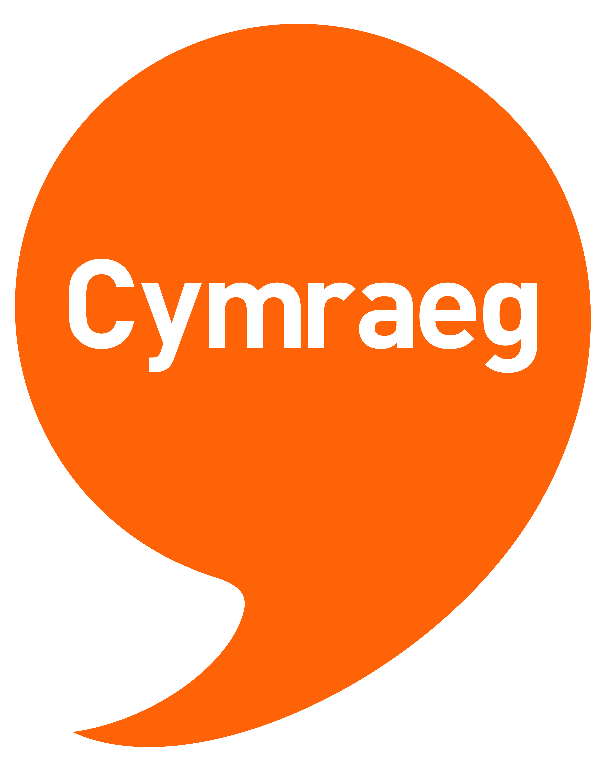

Our Commitment to the Welsh Language

The Welsh language belongs to each of us, whenever and however we become acquainted with it. Anyone involved with Literature Wales will benefit from the Welsh language, whether they are fluent, use a handful of words or expressions, or completely new to the language and curious to know more. Like every modern and creative language, the Welsh language changes and adapts as new generations embrace it. Over the years, a variety of accents and dialects have enriched our literature: from Dewi Emrys to Megan Angharad Hunter, from Y Wenwyseg to Wenglish, Welsh-language words and tones are music to our ears and feed our imaginations.
A truly central part of our mission is to work towards a Wales where the Welsh language thrives, and literature represents our diverse voices. For this to become a reality, we will work with partners to tackle under-representation in the literature sector, to inspire individuals to take action against the climate emergency, and to support the well-being of individuals and communities. We will do all this through the prism of the Welsh language.
Our Welsh Language Development Plan is an important resource which shows our commitment to the language. It identifies areas we can improve, as well as good practice that we can share with others. The Welsh language isn’t an isolated element of our work, rather it is the foundation for all our activity and key priorities; it is the undercurrent of our values. On this strong foundation we will work towards achieving our goals and strive for a more equal, resilient and healthier Wales. In turn, we will contribute to a vibrant Welsh culture that takes pride in the language and shares it with the world. Language and landscape are closely intertwined, and in a similar vein, the Welsh language is a thread running through Literature Wales’ vision of a Wales where literature empowers, improves, and brightens lives.

Why does Literature Wales need a Welsh Language Development Plan?

At a corporate level, the Welsh Language Act 1993 requires all public bodies to apply the principle that the Welsh and English languages should be treated equally. The Well-being of Future Generations Act 2015 also contains references to the Welsh language, as one of its seven goals is to create a Wales of vibrant culture and thriving Welsh language. However, for Literature Wales, the Welsh language is far more than a statutory responsibility. It is a privilege that should be placed alongside literature to be promoted and celebrated.

The number of speakers – According to the Annual Population Survey 2021, undertaken by the Office for National Statistics, 29.5% of people in Wales were able to speak Welsh. The last National Census held in 2021 suggested an even lower percentage of speakers, at 17.8%. Whichever is correct, both indicate that Welsh speakers are in a minority in Wales. Therefore, we will prioritise increasing the number of Welsh speakers within our area of work. Our activities can provide a gateway to attract new speakers to the Welsh language. We should facilitate the use of Welsh by people in Wales when writing and reading, making it both attractive and enjoyable – whether they be fluent or new speakers. We will aim to support a vibrant and viable literature scene through the medium of Welsh – a scene that is both inclusive and welcoming and represents all communities in Wales. We will continue to keep that goal in mind as we develop and deliver activities and will try to ensure that authors and audiences new to the language, or lacking confidence in using it, are encouraged to participate. Through our work, we will support the Welsh Government in its aims to reach one million Welsh speakers by 2050.

Our unique poetic and literature tradition – In our everyday work, we respect literatures in both our languages, but the unique nature of the Welsh poetic tradition requires particular attention in terms of celebrating and highlighting this treasured heritage. Our poetic and literary tradition plays an important part in our history as a nation. It spans the ages, from the work of the primitive bards, to the Poets of the Princes and the Mabinogi, to the Poets of the Nobility, to the development of the National Eisteddfod and the survival of strict metre poetry in more modern times. We will continue to celebrate and support the cynghanedd, our unique myths and legends, and our Welsh language literary tradition by collaborating with partners to raise awareness of these important elements, ensuring that they survive and develop. This work will extend to respecting our unique local dialects and aphorisms, place names, local legends, and more.

Our Priorities and the Welsh Language
Representation and Equality

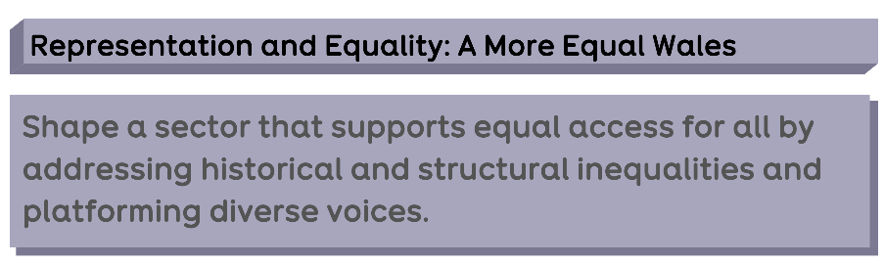

We will ensure that Welsh speakers are fairly represented in our activities. Where possible, our projects will be delivered bilingually. Otherwise, equivalent projects will be delivered in Welsh and English, such as our sister-projects, Bardd Plant Cymru and Children's Laureate Wales. There will be occasional exceptions, such as during the years when our National Poet is not a Welsh speaker. However, we will ensure that advocating for the Welsh language and collaborating with Welsh language communities will continue to be a central facet in such projects – and we will often deliver additional Welsh language projects to ensure linguistic balance as necessary. For further information about how our programmes impact on the Welsh language, see page 6, ‘Our Programmes’.

One of our priorities in 2022-27 will be to ensure that we identify Welsh language speakers within underrepresented groups in our literature. These groups include people from Black, Asian and minority ethnic backgrounds; disabled people; people from low-income backgrounds; the LGBTQA+ community; the Gypsy, Roma and Traveller community; and others. We will work with partners to ensure that all communities in Wales are represented and reflected in our literature and books, by delivering projects to help authors hone their craft and by highlighting pathways within the industry. Part of this work will include working with our partners in the publishing industry to ensure that books by diverse authors are available through the medium of Welsh.

An example of a project: Bardd Plant Cymru

For the first time, a poet from a Black background was appointed to the role of Bardd Plant Cymru. Nia Morais, a poet from Cardiff with family ties to Cape Verde, takes on the role for 2023-25. She was appointed following a competitive process which included a test workshop and an interview. The appointment panel agreed that she had a unique voice and a natural ability to relate to and inspire children. Some of the main objectives of the Bardd Plant project are to increase children's and young people's enjoyment of literature and to empower children and young people through creativity. Literature Wales strongly believes that Welsh writers and literary facilitators must represent the rich diversity our country's population to ensure that literature is relevant to everyone. This is particularly important with children and young people as they look for literary heroes - for writers who reflect them, their families and their communities. Nia will have the ability to appeal specifically to children from ethnic minority backgrounds as well as being a powerful and outstanding Bardd Plant for all the children of Wales.

Health and Wellbeing

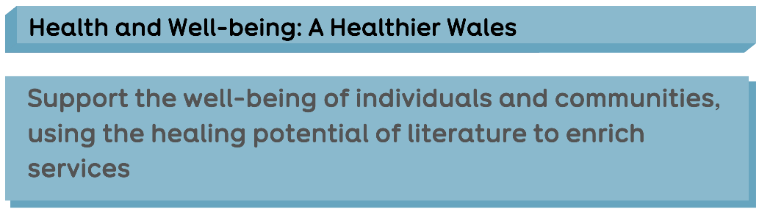

Our work in the field of literature for health and wellbeing often involves vulnerable groups, such as young people suffering from anxiety or mental illness; older people living with dementia; or prisoners and their families. It is essential that Welsh speakers are enabled and allowed to participate in such projects through the medium of their mother tongue. Expressing feelings and emotion, conveying grief and sadness, and writing from the heart are all easier through one’s first language. Frequently, older people, individuals suffering from dementia, and young children are not able to speak a second language. It is therefore crucial that we provide a full programme of health and wellbeing activities through the medium of both Welsh and English, as well as in other languages when possible.

A key part of this work involves training Welsh language facilitators in the field of literature for health and wellbeing, so that they can work in communities to deliver services. Over the next five years, we will address this shortage by delivering training courses through the medium of Welsh with the aim of creating a network of Welsh language literary practitioners to work in communities across Wales. We will also provide training and highlight how facilitators can set up writing or reading groups to implement their learning.

We will also promote the healing power of writing and reading. Clinical trials have shown that creative writing and reading are beneficial to both our physical and mental health. Following her feat of winning the Crown at the National Eisteddfod in 2022, Esyllt Maelor made compelling comments about how much she and the young people she has taught have benefitted through creative writing and reading. We will work with influential individuals within the field to highlight this healing power, continuing to share messages to encourage the practice of writing and reading through the medium of Welsh so as to promote wellbeing.

An example of a project: Writing Well
This is a new programme that develops literary practitioners in Wales. Intensive training, and one-to-one support from a mentor will be provided with the aim of improving the skills needed to facilitate literary activities in the community. Following the training programme, the cohort will develop projects that will benefit the health and well-being of the participants. Three of the six facilitators speak Welsh and are developing Welsh language projects in communities across Wales. These new projects will encourage others to carry out similar activity in their communities. The Welsh-speaking facilitators are specifically interested in working with families from low-income backgrounds, those living with depression and rural communities.

The Climate Emergency
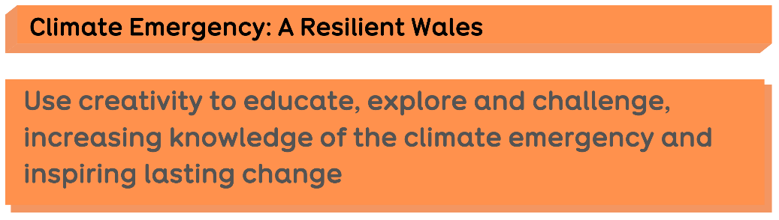

The Welsh language forms a fundamental part of the world’s linguistic ecology, and as a minority language, it faces immense challenges due to the strong influence of more widely spoken languages. A language cannot be detached from its environment, and the history of the relationship between the Welsh language, our literature and our land runs deep. Our ancient legends playfully explain the origin of placenames through onomastic stories; each mountain, lake and cave has its own tale; and our literary greats are all closely associated with their local areas – from Dic Jones to Kate Roberts to Manon Steffan Ros. There is a powerful relationship, therefore, between Welsh language literature and the desire and will to battle against the climate and ecological emergency.

We will use the Welsh language in our climate emergency projects, coining new terms and celebrating with our children and young people the amazing names we have for elements of the natural world. We will support the people of Wales in calling for change, and will do so creatively through their mother tongue. We will celebrate our placenames and our rich dialects – and will work to protect and safeguard the Welsh language on the land.

An example of a project: Lit in Place.
In autumn 2022, three facilitators were selected to represent three Welsh communities, to initiate a long-term literature for health and wellbeing project with group(s) in communities, reflecting on the local impact of the climate emergency. One of these projects will be delivered through the medium of Welsh, another bilingually, and the Welsh language itself will be a crucial element of the project’s infrastructure as it is embedded in the community. Artist and creative Iola Ynyr will run a workshop series entitled Gwledda (meaning ‘to feast’). Working with the wider community of the Rhosgadfan School in Gwynedd, the project will aim to nourish participants using creative writing activities and gaining practical gardening and growing skills. They will meet in the grounds of Ysgol Rhosgadfan, beyond the school itself in the hut, vegetable garden, orchard and wild garden, and draw inspiration from the changes in the natural world. And down in Treherbert, artist Siôn Tomos Owen will work with participants of Welcome to the Woods’ Woodland Therapy Group to create an illustrated diary documenting how the group connects with nature. Woodland Therapy offers a weekly opportunity for participants to combat mental health issues through different activities engaging with nature.

Children and young people and the Welsh language

In developing the use of the Welsh language within literature, we will focus extensively on children and young people. Projects such as the Bardd Plant will broaden children and young people’s access to Welsh language literature and will stoke interest and demonstrate the appeal of writing poetry and taking part in word-play through the medium of Welsh. When possible, the project will select schools based on national statistics; specifically, we will target our activities so that we work with children from low-income backgrounds. The Bardd Plant will also ensure that second language Welsh schools are given the opportunity to enjoy literature and creativity through the medium of Welsh.

We will endeavour to develop new authors who represent all children in Wales to publish books that are relevant to all over the next decade. Representing Wales 2023 focused specifically on literature for children and young people, with the aim of discovering talent so that we can continue to transform the literary and publishing landscape for children and young people over the next few years. We will train underrepresented authors and facilitators to visit schools and deliver workshops, ensuring that literary role models are having an impact across the country.

We will also seek to train teachers, by using Tŷ Newydd to deliver courses on introducing creative writing to children and young people. We will continue to work with Barddas on a campaign to introduce the ‘cynghanedd’ in primary and secondary schools in an accessible and engaging way.

In discussions with the Welsh Government’s Education Department and other national bodies, we will work to ensure that the set texts of the syllabus are relevant and engaging for children and young people, and that stimulating resources are available for teachers under the Bardd Plant branding. We will work closely with the Books Council, especially its Department of Children’s Books and Reading Promotion, to organise World Book Day events and to captivate children more generally through literature.

Our Programmes

National Poet of Wales
As well as promoting Wales’s literary culture to the people of Wales, the National Poet plays an important role in promoting the Welsh language to the world. By participating in literary events beyond Wales, the National Poet will educate audiences about our language’s history and its usage – in poetry and beyond. Hanan Issa, the National Poet 2022-25, is learning Welsh. One of her aims during her term is to bridge Welsh and English language literary communities and to explore the delightful complexities of the ‘cynghanedd’ through the medium of English, introducing it to a new audience. Although she does not write through the medium of Welsh, language will play a central and prominent part in her work as an ambassador over the next three years, and her commission poems will be translated into Welsh, and platformed side by side with the original versions.

Bardd Plant Cymru
As well as nurturing interest in words and a love of words among children and young people, the Bardd Plant’s role has evolved recently as to also champion the Welsh language. Schools are offered opportunities to work with the Bardd Plant as part of their commitment to the Welsh Language Charter, and the way in which the role highlights the fun element of Welsh language poetry clearly inspires children to speak the language. The Bardd Plant project is delivered in partnership with several other organisations that share our vision for the Welsh language, namely S4C, Yr Urdd, the Books Council of Wales and the Welsh Government. We will work with these partners to ensure the Bardd Plant project and its aims reach a large audience and that Welsh poetry engages young audiences as widely as possible. The Bardd Plant’s sister project, Children’s Laureate Wales, although mainly an English language project, will celebrate and promote the Welsh language, and work closely with the Bardd Plant on bridging communities and languages.

The Inspiring Communities Funding Scheme
We will continue to fund various literary events across Wales through the Inspiring Communities Funding Scheme, ensuring equity and prestige for Welsh language events. Oral evidence tells us that this funding allows literary events to be delivered in small communities – often bringing Welsh language speakers together to socialise. We believe that this project plays an important role in enabling socialising through the medium of Welsh in rural communities in particular, and that it helps to ensure that literary and cultural groups can continue to exist.

Writers of Wales Directory
The Writers of Wales Directory on our website offers authors a platform to publicise their achievements and services. It is a digital repository of authors and creative writing facilitators from across Wales. The profiles have been produced and updated by the authors themselves, in their chosen language. Event organisers often use the Writers of Wales Directory to search for workshop facilitators and speakers for literary events. We will make a concerted effort in 2022-27 to ensure that more Welsh language authors have an entry in the Directory, and are confident in promoting themselves and their work.

Tŷ Newydd Writing Centre
Guests from all corners of the world have stayed at Tŷ Newydd Writing Centre. As well as delivering writing workshops, spending time at Tŷ Newydd offers people an introduction to the Welsh language, our traditions and culture. A language leaflet is provided in each bedroom outlining phrases and a brief history of the language for guests, and the language plays a central role in each course – from the welcoming speech to the Eisteddfod chair in the dining room, to the visual effect of the books on the shelves and the artwork and posters on the walls. We will develop our courses for new speakers, ensuring that we deliver at least one course for Welsh learners each year. We will also ensure a stimulating offer for the local community and the wider writing community through the medium of Welsh. The centre will also play an important role in hosting important strategic courses, inviting groups of writers who are underrepresented to network and receive training to develop their craft. Offers for teachers will also be developed to teach the craft of teaching creative writing, and developing their knowledge of contemporary and representative Welsh literature.

Representing Wales
Although attracting equivalent numbers of Welsh and English language authors can be challenging – and this is particularly true of authors with underrepresented characteristics – we endeavour every year to include Welsh language authors in our development programmes. Authors who participate in our intensive development programmes often progress to produce books, performances and collaborations that are widely appreciated by audiences. We will develop a detailed marketing and communications strategy to target Welsh language authors as we develop new rounds of author development programmes – specifically individuals and communities from ethnic minority backgrounds, those living with disabilities or long-term illness, and/or those from low-income backgrounds.

Wales Book of the Year
Each year, the Wales Book of the Year Award places Welsh and English language books and authors on an equal footing – and honours our best literary works. Developing the award into a professional, sought-after and esteemed prize will enable us to reach a wider audience than ever before – drawing interest to the Welsh language through publications. We will continue to work with partners to ensure that we bring authors and books to the attention of readers and the media in Wales and beyond.

Literature for health and wellbeing projects
We believe that providing Welsh language services through literature for health and wellbeing projects is key in enabling participants to express themselves in their first language, and in maximizing the benefit from this service. We will ensure that participants are empowered through words, in whichever language that comes most naturally to them.

Writing Squads
Between 2023-27 and beyond, we hope to stimulate and facilitate the creation of a new network of Writing Squads across Wales, starting with establishing pilot Squads, then a National Squad, and then expanding to offer resources, training and guidance for educators and communities to set up their own Squads for children and young people. The Welsh language will play an integral role with this project, with facilitators encouraging the children to enjoy using the Welsh language in their writing, and have fun in developing their craft. In the long term, our hope is to start young people early on their journey – to grow a strong generation of Welsh writers for the future.

Writing Well and Lit in Place
Writing Well is a new programme to develop facilitators with underrepresented life experiences to go into communities that need the power of literature to help them with their health and well-being. Lit in Place will continue to invest in long term hyperlocal projects in communities to draw attention to the climate emergency and well-being through literature. Again, Welsh language projects will feature heavily within this project, ensuring the Welsh language is at the forefront of discussions about the environment, well-being and literature.

Pencerdd
In partnership with Barddas, this new programme will develop five new poets to master the ancient craft of cynghanedd. The poets will receive mentorship, and will take part in various events to hone their skills.

Our offer for Welsh learners or new speakers
By creating a culture of respect and enthusiasm towards the Welsh language within our offices and networks, we will encourage those who are not fluent Welsh speakers in our team to learn and enjoy using the Welsh language. Offers such as a Teams group for new speakers will be made to encourage discussions about the Welsh language and to provide new speakers with an opportunity to practise and ask questions about the language; fluent members of the team will offer their services as buddies or informal language mentors; and we will encourage the holding of coffee mornings for Welsh speakers to practise their skills.
Tailored language awareness training will be arranged every three years and will be provided for all staff and Trustees. It will inform staff about legislation and policy, but also about more interesting aspects – placing the Welsh language and its literature in its historical and cultural context. We will encourage staff who are new Welsh speakers and staff who do not speak Welsh to visit the National Eisteddfod and other notable Welsh language events, supporting and assisting them as they visit for the first time.
Board Meetings will also place an emphasis on the language, with members encouraged to speak Welsh and take advantage of the simultaneous translation service. We will ensure that company documents are always available bilingually, that Welsh language versions are of equal quality to the English language versions and that they are reader friendly without unnecessary jargon.
Literature Wales will commit to providing an opportunity for new speakers within the team to attend one annual 5-day residential/online Welsh course at the intermediate or higher level, without having to take annual leave, in addition to a commitment to pay up to £150 a head towards the annual costs of Welsh language lessons. Staff taking advantage of the offer to attend a 5-day residential course will be encouraged to implement their learning at work, and to share their experiences during a staff meeting.
Beyond our organisation, we will try and encourage our authors and participants to always engage with the Welsh language. For instance, we will do this by working with the National Centre for Learning Welsh to offer lessons to our Representing Wales cohort and other writers who are involved in our projects; by delivering writing courses for Welsh learners at Tŷ Newydd; and by communicating that we welcome new speakers or less confident Welsh speakers on our Welsh language programmes, and more.

Translating and proofreading
Much of our translating and proofreading is undertaken internally by bilingual members of the team. We are currently reviewing and reassessing our translation and proofreading processes and arrangements so that this work does not impact excessively on specific members of the team, and that sufficient time is allowed to ensure that translation/proofreading requests can be fulfilled to a high standard.

Translations should be undertaken with due care and respect, ensuring that Literature Wales’s voice is confident, easily understood and appropriate. Texts should not sound like translations and the aim should be to produce a natural, flowing form of Welsh. When possible, fluent members of the team should produce press releases and stories in Welsh in the first instance, so that Literature Wales’s correspondence develops a natural Welsh language voice.

Contributing to the sector more widely
As a bilingual company that is proud of operating within the Arts Council’s portfolio, Literature Wales has a responsibility to contribute towards discussions about the Welsh language and its culture within our sector and in the public sphere. We will attend arts networks such as What Next | Beth Nesaf and will contribute through the medium of Welsh and on behalf of the Welsh language. We will assist partners such as the National Eisteddfod, the Books Council of Wales and Barddas to ensure that Welsh literature is given a platform and is represented in a fair and stimulating manner.
We will work closely with the Welsh Enabler at the Arts Council of Wales on their Welsh Language Strategy and will work with other members of the arts portfolio to be innovative and enterprising, and to share good practice. Since 2022, our Tŷ Newydd centre has been used by the Steering Group on the Arts Council’s Welsh Language Strategy.

Welsh Language Commissioner Attachments
Our Cynnig Cymraeg – Welsh Offer
As a proud bilingual national company, we are committed to offering a quality service in both Welsh and English according to client preference; to deliver projects and support work in Welsh and English; and to promote the Welsh language and its importance in all aspects of our work.
- Welsh speaking members of staff will be available to deal with telephone, email and face to face enquiries at all times
- All information we publish on our website and social media channels will be available in Welsh as well as English
- Our projects will celebrate the richness of Wales' literary culture in both languages, and aim to develop the craft of new writers to create good creative writing in both English and Welsh, encouraging a vibrant literary and artistic scene
- We will aim to support the Government's target of reaching one million Welsh speakers by 2050 by investing in exciting and innovative projects through the medium of Welsh
- By welcoming guests to Tŷ Newydd Writing Centre from beyond Wales, we will educate them about the Welsh language and the unique culture of Wales

Review period
We will review the plan every 3 years to ensure that our objectives remain aligned with those of the Commissioner.
This update: January 2024. Approved by Literature Wales’ Board of Trustees.

Our provision at present | Level | What we intend to do next.  How will we maintain, or increase this level of provision?  What are the performance indicators? | Who is responsible? | By when?
Customer interaction
Face to face  Welsh-language staff are always available to greet customers in Welsh | □ | We have established procedures to ensure that Welsh-speaking staff are available in both offices at all times, and in every face-to-face event. All staff will happily direct anyone wishing to converse in Welsh to a Welsh speaking staff member.  We will encourage Welsh speaking staff to wear a ‘iaith gwaith’ badge or lanyard when interacting with the public, so that they are easily recognised. | Senior Leadership Team | Ongoing
Telephone services  Every officer answers the phone with a bilingual greeting. If they’re not Welsh speakers, they will offer to transfer the call to a Welsh speaking officer | □ | All staff are advised to transfer Welsh language phone calls to the relevant Welsh speaking officers; and all staff members offer a simple bilingual greeting.  Provide a sheet of Welsh phrases to all staff to assist them with the Welsh language, as well as providing more training. | Senior Leadership Team | Ongoing
Replying to letters and emails  What is your normal routine when replying to letters and emails sent to you in Welsh?  We reply in Welsh to any correspondence we receive in Welsh, and this doesn’t affect the time it takes for us to reply  Welsh speaking staff are always ready to assist others to write messages.  It’s also good practice for staff to include Welsh-language, or bilingual, greetings in English correspondence.  We correspond bilingually first, asking respondents to note their language preference and/or wait to see in what language the recipient replies.  Welsh-language staff are always readily available to assist speakers who are not fluent to write suitable bilingual messages. | □ | We will create a short document of bilingual greetings to share colleagues to use in their e-mails as good practice.  We will continue to underline the importance of bilingual correspondence.  Email sig files have been adapted to include a ‘Please Write to me in Welsh or English’ or ‘I am learning Welsh’ statement. | Senior Leadership Team | Ongoing
Iaith Gwaith  Showing the 'Iaith Gwaith' logo is an easy way of showing that you offer a Welsh language service.  We permit Welsh speaking officers to wear Iaith Gwaith resources | □ | We have a stock of ‘Iaith Gwaith’ resources for staff use and we will make more effort to demonstrate our commitment to ‘Iaith Gwaith’ objectives – including displaying posters and encouraging our staff to wear badges and lanyards in the Office – but more specifically when interacting with the public. | Senior Leadership Team | Ongoing
Image
Your company or organisation’s name  Our name is bilingual, or Welsh only | □ | Continue to encourage staff to use the company’s full title when corresponding in English – Llenyddiaeth Cymru | Literature Wales. | Senior Leadership Team | Ongoing
Please note if the following are available in:

Business cards, Headed paper, Marketing materials – e.g. Pop-ups / Banners / Posters (static and digital), signs and publications, e.g. information leaflets  Welsh and English equal | □ | All our business cards headed paper and marketing materials, signs and publications are bilingual, and is a requirement when re-ordering or re-designing resources. | Comms and Marketing Team and/or Office Managers | Ongoing
Email signatures  Welsh and English equal | □ | All of the Email signature templates, and automatic replies are bilingual. This is a requirement when re-designing resources. We have a statement of our dedication and ability to communicate bilingually on our e-mail signatures. | Comms and Marketing Team | Ongoing
Social media profiles  Welsh and English equal | □ | Llenyddiaeth Cymru | Literature Wales operates social media accounts in both Welsh and English. Welsh and English messages are shared within the same timeframes. | Comms and Marketing Team | Ongoing
Digital | □
Website  Our website is fully bilingual, and the Welsh and English pages are updated often. It’s possible to move from the Welsh version to the English at any point using the language choice button | □ | The only section that is not available bilingually is the blog entries that have been written by visitors e.g. reviews. We will continue to keep an eye on the situation, and if we believe that one language receives more attention than the other, we will attempt to identify funds to translate the content. | Comms and Marketing Team | Ongoing
Social Media  If your approach isn’t consistent across all your social media platforms, select the most relevant, you can then reflect on the differences in your action plan.  Each message is posted bilingually at the same time | □ | Llenyddiaeth Cymru | Literature Wales operates social media accounts in both Welsh and English (separate accounts for Llenyddiaeth Cymru and Literature Wales; and one account for Tŷ Newydd Writing Centre which sends bilingual messages with the Welsh First). Welsh and English messages are set within the same timeframes (Within a minute of publishing the other will be shared). | Comms and Marketing Team | Ongoing
Events
Attendees’ language choice  If organising an event, do you ask attendees what their language choice is before the event, or during registration? We note that they are welcome to contribute to any discussions in Welsh or English. | □ | We offer language choice in our meetings and public events. This is supported through the provision of an interpreting service. | Senior Leadership Team | Ongoing
When you organise an event that’s open to the public in which language are the following:

Invitations  Welsh and English equal | □ | All of our invitations are bilingual, which is a requirement when re-ordering or re-designing resources. | Senior Leadership Team | Ongoing
Forms e.g. booking / registration / evaluation  Welsh and English equal | □ | All of our registration forms etc. are bilingual, which is a requirement when re-ordering or re-designing resources. | Senior Leadership Team | Ongoing
Publications e.g. programme / attendee pack  Welsh and English equal | □ | All of our event publications are bilingual, which is a requirement when re-ordering or re-designing resources. | Senior Leadership Team | Ongoing
Speakers / announcements  Welsh and English equal | □ | We provide a mixture of conversations in Welsh and English in our meetings and public events. This is supported through the provision of an interpreting service. | Senior Leadership Team | Ongoing
Signs  Welsh and English equal | □ | All of our signs are bilingual, which is a requirement when re-ordering or re-designing resources. | Senior Leadership Team | Ongoing
Banners / pop ups / displays  Welsh and English equal | □ | All of our banners are bilingual, which is a requirement when re-ordering or re-designing resources. | Senior Leadership Team | Ongoing
Staff or volunteers to greet visitors / competitors  Welsh and English equal | □ | During public events there are staff with various degrees of proficiency in the Welsh language; those who are Welsh speaking, Welsh learners, and non-Welsh speakers. There will also be Welsh speaking staff on hand to greet any customers on our stall. All staff will happily direct anyone wishing to converse in Welsh to a Welsh speaking staff member.  We will encourage Welsh speaking staff to wear a ‘iaith gwaith’ badge or lanyard when interacting with the public to be more easily recognised. | Senior Leadership Team | Ongoing
Tickets (ticket booking system e.g. tocyn.wales / eventbrite?)  Welsh and English equal | □ | We tend to sell tickets internally rather than use an external system, but we will always ensure that we are able to offer the service in Welsh when using an external software or system. | Senior Leadership Team | Ongoing
Providing courses e.g. training  Equal number of courses in both languages | □ | Whilst some of our training sessions will be in Welsh or English only (without translation facilities), we will attempt to ensure that equal number of sessions are provided in both languages, and invest more in simultaneous translation provision.  Any learning materials are available in Welsh and English. We promote the courses bilingually. | Senior Leadership Team | Ongoing
Workforce development
Recruiting staff and volunteers  To what extent do you consider the Welsh language when recruiting staff and volunteers?  We note Welsh language skills as being desirable for all positions | □ | Llenyddiaeth Cymru | Literature Wales’ recruiting strategy prioritises that Welsh language staff are present in both its offices. Depending on the role in question, we will sometimes state that Welsh is essential for the role. We ensure that each team is able to offer Welsh service that is equal to the English.  We value the ability to use the Welsh language as a skill, and it plays an important role in our recruiting process. | Senior Leadership Team | Ongoing
Advertising vacant posts  We advertise every post bilingually | □ | All job advertisements are prepared bilingually, treating both languages equally. We place the adverts in Welsh language media and on partners’ sites in Wales. | Comms and Marketing Team | Ongoing
Recording the Welsh language skills of your workforce  We regularly update our records to ensure we are fully aware of the Welsh language skills of our officers | □ | Language skills (reading, writing, speaking) are assessed during the interview if relevant, and play an important role in our professional development performance assessment.  Welsh language speaking, reading, and writing skills are continually assessed at work, and if required, further training will be provided. | Senior Leadership Team | Ongoing
Informing your workforce about your Welsh language services.  How do you ensure that your officers know which Welsh medium services your organisation offers?  Every officer is made aware of our Cymraeg Offer during their induction | □ | Welsh language awareness is a part of every staff member’s induction Process.  We inform officers of resources such as Cysill and To Bach, which support using Welsh in the workplace. We promote opportunities to learn Welsh through Cymraeg Gwaith to all staff members, and the organisation can offer work hours towards learning. | Senior Leadership Team | Ongoing
Working with contractors and partners  When you contract another organisation to provide a service on your behalf, or to work in partnership with you, how do you secure commitment to the Welsh language.  There is no formal process, however we work closely with our providers and feel able to monitor their commitments to our Welsh language provision | □ | Having this plan in place will enable us to offer it as a part of the information package about us to contractors and/or partners in the future.  Our commitment to the Welsh language will always remain key when organising partnership projects and will play an important role in any project development work. | Senior Leadership Team | Ongoing
Contracts  Do you offer Welsh-language contracts? | □ | Our contracts for Writers of freelancers are available in both languages. We will ask the recipients for their choice of language. | Everyone | Ongoing
Learning and using the Welsh language  It’s possible that you may be able to benefit from free Welsh language training through the National Centre for Learning Welsh.  We are happy to release staff during working hours for courses and pay for a portion of the course | □ | We will pledge to offer staff who are new Welsh speakers the opportunity to attend one 5-day Higher or Canolradd course online or residentially to learn Welsh during the year without having to take annual leave, and further to this, we will contribute up to £150 per staff member for Welsh lessons fees. | Senior Leadership Team | Ongoing
Internal Staff Meetings  Due to the cost of simultaneous translators and the informal nature of our internal staff meetings, nearly all our internal staff meetings are held in English with only a few sentences in Welsh now and again. | □ | Bilingual staff members are encouraged to provide bilingual updates, and this happens occasionally.  Encourage more Welsh-language only meetings, or bilingual meetings – or more frequent smaller meetings where Welsh language staff come together. | Senior Leadership Team | Ongoing

https://gov.wales/welsh-language-data-annual-population-survey-2021
https://www.gov.wales/welsh-language-wales-census-2021-html
Line Manager permission should be sought in advance, ensuring that the period in question does not impact excessively on the company’s work or on other members of the team. Each training opportunity will be agreed as part of a member of staff’s professional development plan.
Line Manager permission should be sought in advance, ensuring that the period in question does not impact excessively on the company’s work or on other members of the team. Each training opportunity will be agreed as part of a member of staff’s professional development plan.

