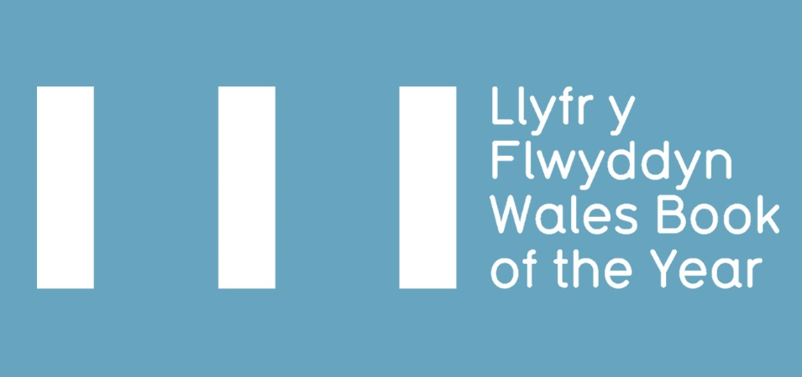

WALES BOOK OF THE YEAR AWARD 2023 – SUBMISSION PACK

- ELIGIBILITY CRITERIA
- TERMS & CONDITIONS
- ENTRY FORM 2023

Deadline for submissions: Monday 5 December 2022*
* If you foresee any issues with submitting a book by the deadline,
please contact us before 5 December 2022 to discuss.

Wales Book of the Year is an annual literary award celebrating the best Welsh works published within a calendar year in the fields of creative writing and literary criticism in both Welsh and English. Managed by Literature Wales, and supported by partners across the literary sector, the awards are presented in four categories: Poetry, Fiction, Creative Non-Fiction, and Children & Young People.
There are twelve awards in total with a collective prize fund of £14,000. In both Welsh and English there are four category winners, one People’s Choice winner and one overall winner.
The short list, which will comprise of three books in each category, will be announced in the spring, with the winners of Wales Book of the Year 2023 announced during the summer.

All shortlisted books are eligible for the independent People’s Choice Awards run annually. The vote will open after the short list has been announced and the winners will be revealed at an awards ceremony during summer 2023.

ELIGIBILITY CRITERIA
Please read and familiarise yourself with the eligibility criteria for Wales Book of the Year before making an application.

NECESSARY:
- Must be published for the first time (in either Welsh or English) in the calendar year preceding the award (1 January – 31 December 2022.)
- The author(s) must have been alive on the date the book is submitted to Literature Wales.
- Work from multiple writers may be considered, however the volume as a whole must create a new and distinct literary work and be of clear relevance to Wales and Welsh culture*. For example, anthologies of disconnected work by multiple writers will not be eligible.
- Be comprised of work which has not been previously published in individually authored collections (collections containing some previously published work - for example, individual poems published in magazines - will not be excluded.)
- Be a work of poetry, fiction, or creative non-fiction (see note below), OR intended for children & young people with a readership up to the age of 16.
- Must be in print from the date the short list is released until the winners are announced at the award ceremony.
- Work presented to the Poetry, Fiction, or Creative non-fiction categories must be intended for an adult readership.
- Be submitted to one category only.
- Work published bilingually can only be submitted for consideration in one language - the language in which the work was originally written.

Plus at least one of the following:
- Be written in the Welsh language.
- Be written in English by a Welsh-born writer, or someone who was schooled in Wales.
- Be written in English by a writer who is currently resident in Wales
- Be of clear relevance to Wales and Welsh culture (see definition below).
If you submit a book under this condition (4) only, a short supporting statement must be submitted with the application form, clearly explaining the case for relevance (maximum 250 words).

*Definition of works which are of clear relevance to Wales and Welsh culture
Titles which discuss and/or add to themes which have a tradition of discourse in Welsh literary fields can, on occasions, be determined eligible for consideration despite the writer having no linguistic, residential, or adolescent links with Wales.
The following are not eligible for consideration:
- Individual work published within anthologies of multiple writers, or anthologies of multiple writers where the collection as a whole does not create a distinct literary work, or collections primarily consisting of previously published work
- Translations and adaptations
- Scripts, screenplays, and picture books

Decisions on all eligibility issues will be at the discretion of Literature Wales.

THE CATEGORIES ARE DEFINED AS:
- Poetry
A collection of new work by a single or multiple authors, intended for adult readership.
- Fiction
A new work by a single or multiple authors which is intended for adult readership. We welcome all fiction genres.
- Children & Young People
A new work by a single or multiple authors which primarily consists of literary rather than pictorial content. Books will be intended for readership up to 16 years of age. Fiction, Poetry and literary non-fiction are all eligible and must meet the criteria detailed in a, b & d, except for readership age.

- Creative non-fiction
We define creative non-fiction as a non-fictional narrative where the creativity of prose is central to the nature of the work. Types of literature which could fall under such criterion include, but is not limited to, memoirs, biographies, social history, or travel writing.

Work that is primarily academic or factual is unlikely to be considered for this category unless a strong narrative and creative component can be demonstrated. If this is not evident from the title and blurb, please provide a short supporting statement clearly explaining the case for relevance (maximum 250 words).

Decisions on all eligibility issues will be at the discretion of Literature Wales. Decisions will be final and confirmed after the closing date.
If you are in any doubt about the eligibility of a book for Wales Book of the Year, please contact Literature Wales: LLYF-WBOTY@literaturewales.org

TERMS AND CONDITIONS
To submit your books, please send one physical copy and a pdf and/or eBook copy of each title to the below addresses by Monday 5 December 2022:

PDF/eBook:
LLYF-WBOTY@literaturewales.org

Physical copy:
Wales Book of the Year,
Literature Wales,
Glyn Jones Centre,
Wales Millennium Centre,
Bute Place, Cardiff,
CF10 5AL

*To reduce the environmental impact of the award we are asking you to submit one physical copy and a pdf and/or eBook of each book. If the file is too large to attach in an email, please send via WeTransfer, OneDrive, or another file sharing method.

Please note, we may seek up to 4 additional hard copies of the book from you to assist with the judging process or for marketing purposes.

Additionally, please also attach a completed copy of this form along with the following items for each book submitted:
- a hi-res picture of the book cover (including any relevant credits)
- a hi-res picture of the author (including any relevant credits)
- the Advance Information Sheet (AI/AIS) for the book, if available
- a short description/blurb of the book
- a short biography of the author and contact details (email)

Please note: Literature Wales will confirm submission of titles only when all of the above items have been received.
- It is the publisher’s responsibility to secure the agreement of authors to submit books and information to the Wales Book of the Year Award.

- Any physical copies submitted by publishers will be used for the purposes of judging, marketing, and administrating the award. It is not possible to return any books.
- It is the publisher’s responsibility to indicate to which category each book is submitted. If the judges would like to consider the book for a different category, Literature Wales will inform the publisher/author.

- It is the publisher's responsibility to indicate how any cash prizes and / or trophies should be split in the event of a book written by multiple writers winning any of the categories or overall awards.

- As a condition of entry, publishers agree to cooperate with Literature Wales and its partners to promote Wales Book of the Year.

- Shortlisted authors are expected to co-operate with the press following relevant announcements, as well as with Literature Wales to promote the award and attend the 2023 ceremony (plans will be announced in the new year).
- Shortlisted writers and winners will be required to be available for interviews following the announcements, including co-operating with Literature Wales to create promotional videos to promote the awards and their work (click here to see examples from previous years).
- Judges may consider non-submitted books, provided they comply with the eligibility criteria. Literature Wales will contact the publisher to request further books and information in this case.

2023 ENTRY FORM

Publisher

Contact Name
Email address
Phone number

English-language books
Title | ISBN | Author | Date of publication | Category

Welsh-language books
Title | ISBN | Author Name | Date of publication | Category

I confirm that:
- the above writer(s) have agreed to the submission and sharing relevant information with Literature Wales | Wales Book of the Year Awards.
- the above title(s) comply with the Wales Book of the Year Eligibility Criteria, and that I have read and agree with the Terms & Conditions.
- the publisher agrees that Literature Wales may use the promotional material submitted (illustrations on book covers, book blurbs and author biographies and pictures) for the purposes of promoting the Wales Books of the Year Awards.
- the publisher agrees to support Literature Wales with marketing any books they submit to the award that reach the short list or win any awards.
- the publisher agrees to send Literature Wales up to 4 additional physical copies of the books to support the judging or marketing process if requested.

Name:
Position:
Signed:
Date:

