Writer Commissions:
Nature and the Environment for Well-being
Deadline for Expressions of Interest:
12.00 noon on Monday 21 March 2022

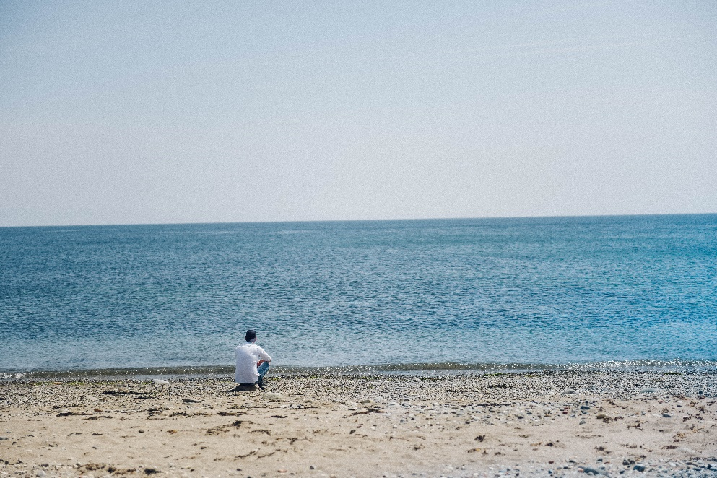

Literature Wales, in partnership with Natural Resources Wales, is inviting expressions of interest from writers and creative facilitators to devise and deliver a creative writing project which focuses on improving health and well-being.
We believe that literature has the power to improve and transform lives. We all know being in nature is good for our emotional well-being and immersing ourselves in the great outdoors and writing about its wonders can also help us emotionally. As our concerns about the climate emergency and the pandemic grow, many of us have been enjoying our natural environment more than ever before.
We are therefore inviting artists to devise a project which explores the connection between literature, well-being, and the natural environment. 3 commissions of £4,000 each are available. Facilitators can submit an expression of interest individually, in pairs, or as a collective. Our Tŷ Newydd Writing Centre can also be made available as an in-kind resource for a residential, or a non-residential event subject to availability.
We will prioritise projects which consider a legacy in the long term, and at least one of the commissions will be awarded to activity delivered in the Welsh language. We are especially interested in establishing a project in the Llanystumdwy area, with the aim of offering long-term support for its legacy through our base at the Tŷ Newydd Writing Centre.

Aims & Objectives:
- To provide innovative and new creative activity exploring literary activity in nature and in the local community supporting good mental health and well-being
- To provide opportunities for early career writers and creative audiences to develop or learn new skills
- To provide a tangible outcome that can be upscaled and shared as a blueprint for future projects in other areas of Wales
- Preferably to work in partnership with a local (voluntary/third sector) organisation experienced in supporting people to enjoy their local natural environment and to set up long-term initiatives in the community
- To provide freelance writers paid work in a time where they face economic uncertainty as a result of the pandemic
- To entertain participants and audiences with exciting, entertaining, and engaging literary content
- To use digital platforms and physically distanced face-to-face activity to bring creative audiences and communities together through literature.

Outputs:
- Each project must engage with at least 10 participants, but we will prioritise projects that can engage with more. Literature Wales are especially interested in working with participants who are under-represented within Wales’ literary community, e.g. those from Black, Asian, or minority ethnic backgrounds; those who identify as disabled or who have a long-term health condition; those at risk of illness through loneliness; and those from low-income backgrounds. We are also interested in multi-generational groups.
- Projects must deliver at least 8 sessions (or approximately 8 hours) to the target group and produce a finished project at the end which can be showcased and used as a template for future development. E.g., a book, performance piece, a film, a mural, a local exhibition, a garden.
- Projects must provide creative participation activities, such as writing workshops and creative nature walks.
- Projects must include a strong literature/creative writing element, but can also include other artforms such as illustration, music, and dance.
- Projects must be documented and evaluated in detail.
- Artists must attend a mandatory half day online information/training session as part of the commission – covering introductions to all artists and partners safeguarding, monitoring & evaluation.
Literature Wales staff will be available to assist with all elements of development, and to support delivery, evaluation, and monitoring.
What's Available?
There are 3 commissions available worth £4,000 each.
Writers can apply for one commission only; however, you are welcome to submit an expression of interest individually, in pairs or as a collective.

Eligibility Criteria
All Wales-based freelance writers are eligible for this opportunity, but we will prioritise writers who have not received commissions or paid work from Literature Wales in the past 12 months.
The selection panel will consider many elements during the decision-making process, including prioritising those who are under-represented within Wales’ literary community. Potential, enthusiasm, and freshness of ideas will be considered as important as experience, and linguistic and geographical balance might be taken into consideration.

How to apply
To express your interest in this opportunity, please complete the application form here (if you would like to read the application form before attempting to fill it in, you can do so here). The application form will ask for your personal details, including details which will help us assess eligibility and information about your career so far.
You will also be asked to submit a draft project idea and budget.
You can also apply by sending a video answering the application form questions. Video applications can be sent through a Dropbox or WeTransfer link. If sending your application in video form, please also send an email containing your contact details.
Please send your application, or any questions about the role, to post@literaturewales.org, with Nature and the Environment for Well-being in the subject line.
Expressions of Interest must be sent to Literature Wales by 12.00 noon on Monday 21 March 2022

What happens next?
Your application will be assessed by representatives from Literature Wales and Natural Resources Wales. Each application is presented to the panel anonymously, to assess each proposed project/content based on its own potential or merit.
The panel includes individuals from a variety of linguistic and ethnic backgrounds and represent expertise in different areas of our work including communications, participation, writer development, monitoring and evaluation, representation and equality, health, and well-being and climate emergency.
The panel may wish to invite applicants to discuss their projects in further detail. Should this be the case, the meetings would take place on Thursday 24 March 2022.
Successful applications will be selected and confirmed with each writer by Tuesday 29 March 2022. At this point, Literature Wales will confirm the exact funding offered, and will agree a completion date with each writer.
We expect the successful projects to start in April 2022.

Our recruitment policy

Literature Wales benefitted from being a part of the Weston Jerwood Creative Bursaries, which support arts organisations to expand their approach to diverse recruitment and talent development. We are committed to welcoming candidates from a wide range of backgrounds, which includes assessing applications partly based on potential strengths. If you would like to apply for this opportunity but are uncertain whether you have sufficient experience, please contact us for an informal chat.

Budget
Each commission is worth £4,000. The facilitator, or team of facilitators, must consider and include their own fee within this budget in developing and delivering this project. Facilitators are free to dictate their own daily rate based on experience and expertise.
Tŷ Newydd Writing Centre can also be made available to your project as an in-kind resource for a fully catered short residential stay (2 nights maximum), or a non-residential event subject to availability. Any travel costs for participants attending Tŷ Newydd must be considered within the project budget.
We have included a Budget Breakdown example below. Please get in touch if you would like assistance with the budget forecasting plan.

Budget Example
Item | Individual Cost | Number Needed | Total Amount
Facilitator Fee: Developing Project (including partner meetings; preparation monitoring and evaluation work) | Day rate @ £300 | 3 | £900
Facilitator Fee: 4 full days of workshops (or 8 half-day workshops) | Day rate @ £300 | 4 | £1200
Secondary Guest Facilitator fee (e.g., running a nature walk) | £300 | 4 | £1200
Workshop Materials | £100 | 1 | £100
Creation of end product | £600 | 1 | £600
Total |  | £4000

Please consider the environmental impact if/when traveling to deliver this project, however, don’t forget to consider facilitators and participants’ travel expenses in your budget if relevant.
Please do not hesitate to contact Literature Wales if you would like to discuss your project ideas further. Please contact post@literaturewales.org

