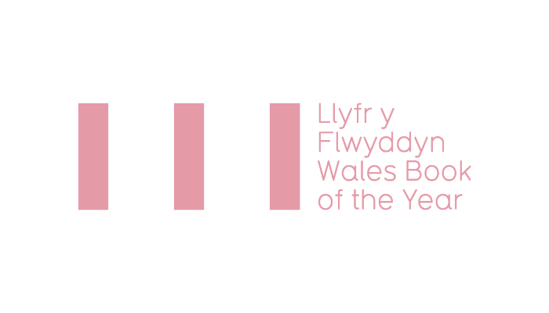

WALES BOOK OF THE YEAR AWARD 2022 – SUBMISSION PACK

ELIGIBILITY CRITERIA
TERMS & CONDITIONS
ENTRY FORM 2022

Deadline for submissions: Monday 13 December 2021*
* If you are submitting a book that will be published during December 2021 and cannot submit copies of the book by the deadline, please contact us to discuss before 13 December.

Wales Book of the Year is an annual literary award celebrating the best Welsh works published within a calendar year in the fields of creative writing and literary criticism in both Welsh and English. Managed by Literature Wales, the awards are presented in four categories: Poetry, Fiction, Creative Non-Fiction, and Children & Young People.
There are twelve awards in total with a collective prize fund of £14,000. In both Welsh and English there are four category winners, one People’s Choice winner and one overall winner.
The Short List, which will comprise of three books in each category, will be announced in the spring, with the winners of Wales Book of the Year 2022 announced during the summer.

All shortlisted books are eligible for the independent People’s Choice Awards run annually. The vote will open after the shortlist has been announced and the winners revealed at an awards ceremony during summer 2022.

ELIGIBILITY CRITERIA
Please read and familiarise yourself with the eligibility criteria for Wales Book of the Year before making an application.
NECESSARY:
- Be the sole work of one writer OR a collaboration between 2 authors (illustrations and introductions excluded.)
- Be published for the first time (in either Welsh or English) in the calendar year preceding the award (1 January – 31 December 2021.)
- The author(s) must have been alive on the date the book is submitted to Literature Wales.
- Be comprised of work which has not been previously published in individually authored collections (collections containing some previously published work - for example, individual poems published in magazines - will not be excluded.)
- Be a work of poetry, fiction, or creative non-fiction (see note below), OR intended for children & young people with a readership up to the age of 16.
- Must be in print from the date the Shortlist is released until the winners are announced at the award ceremony.
- Work presented to the Poetry, Fiction, or Creative non-Fiction categories must be intended for an adult readership.
- Be submitted to one category only.
- Work published bilingually can only be submitted for consideration in one language.
Plus at least one of the following:
- Be written in the Welsh language.
- Be written in English by a Welsh-born writer(s), or someone who was schooled in Wales.
- Be written in English by writers who currently reside in Wales.
- Be of clear relevance to Wales and Welsh culture (see definition below)
If you submit a book under this condition (4) only, a short supporting statement must be submitted with the application form, clearly explaining the case for relevance (maximum 250 words).
Definition of works which are of clear relevance to Wales and Welsh culture
Titles which discuss and/or add to themes which have a tradition of discourse in Welsh literary fields can, on occasions, be determined eligible for consideration despite the writer having no linguistic, residential or adolescent links with Wales.
The following are not eligible for consideration:
- Work published within anthologies of multiple writers
- Translations and adaptations
- Scripts, screenplays, and picture books
Decisions on all eligibility issues will be at the discretion of Literature Wales.

THE CATEGORIES ARE DEFINED AS:
- Poetry
A collection of new work, intended for adult readership.
- Fiction
Eligible books submitted to this category must be new work which is intended for adult readership. We welcome all fiction genres.
- Children & Young People
Submissions to the Children & Young People’s category must be new work and primarily consist of literary rather than pictorial content. Books will be intended for readership up to 16 years of age. Fiction, Poetry and literary non-fiction are all eligible and must meet the criteria detailed in a, b & d, except for readership age.
- Creative non-fiction
Creative non-fiction is defined as prose writing which is either primarily creative in nature or discursively engages with other’s fiction, non-fiction or poetry. Types of books which could fall under such criterion include travel writing, autobiography/biography and social history.

Decisions on all eligibility issues will be at the discretion of Literature Wales. Decisions will be final and confirmed after the closing date.
If you are in any doubt about the eligibility of a book for Wales Book of the Year, please contact Literature Wales: LLYF-WBOTY@literaturewales.org

TERMS AND CONDITIONS
To submit your books please send six copies of each title to the following address by Monday 13 December 2021:

Wales Book of the Year
Literature Wales
Glyn Jones Centre
Wales Millennium Centre
Bute Place, Cardiff
CF10 5AL

Additionally, please send a copy of this form to LLYF-WBOTY@literaturewales.org along with the following items for each book submitted:
- a hi-res picture of the book cover (including any relevant credits)
- a hi-res picture of the author(s) (including any relevant credits)
- a short description/blurb of the book
- a short biography of the author(s) and contact details (email)
Please note: Literature Wales will confirm submission of titles only when all of the above items have been received.
- It is the publisher’s responsibility to secure the agreement of authors to submit books and information to the Wales Book of the Year Award.
- The six copies of books supplied by publishers are used for judging, administrative and publicity purposes. We are unable to return books.

- It is the publisher’s responsibility to indicate to which category each book is submitted. If the judges would like to consider the book for a different category, Literature Wales will inform the publisher/author.

- As a condition of entry, publishers agree to co-operate with Literature Wales and its partners to promote Wales Book of the Year.

- Shortlisted authors are expected to co-operate with the press following relevant announcements, as well as with Literature Wales to promote the award and attend the 2022 ceremony (plans will be announced in the new year).
- Shortlisted writers and winners will be required to be available for interviews following the announcements, including co-operating with Literature Wales to create promotional videos to promote the awards and their work (click here to see examples from previous years).
- Judges may consider non-submitted books, provided they comply with the eligibility criteria. Literature Wales will contact the publisher to request further books and information in this case.
- If a collaboration by two authors wins a category, including the overall award, any associated prizes will be shared between the authors.

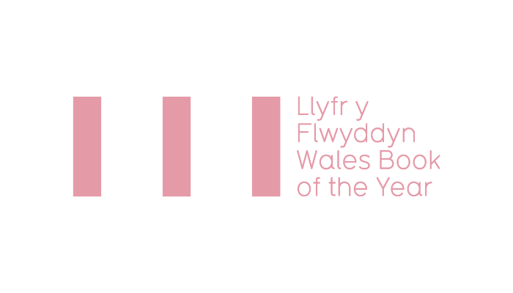
2022 ENTRY FORM

Publisher

Contact Name
Email address
Phone number

English-language books
Title | ISBN | Author(s) | Date of publication | Category

Welsh-language books
Title | ISBN | Author(s) | Date of publication | Category

I confirm that:
- the above writer(s) have agreed to the submission and sharing relevant information with Literature Wales | Wales Book of the Year Awards.
- the above title(s) comply with the Wales Book of the Year Eligibility Criteria, and that I have read and agree with the Terms & Conditions.
- The publisher agrees that Literature Wales may using the promotional material submitted (illustrations on book covers, book blurbs and author biographies and pictures) for the purposes of promoting the Wales Books of the Year Awards.

Name:
Position:
Signed:
Date:

