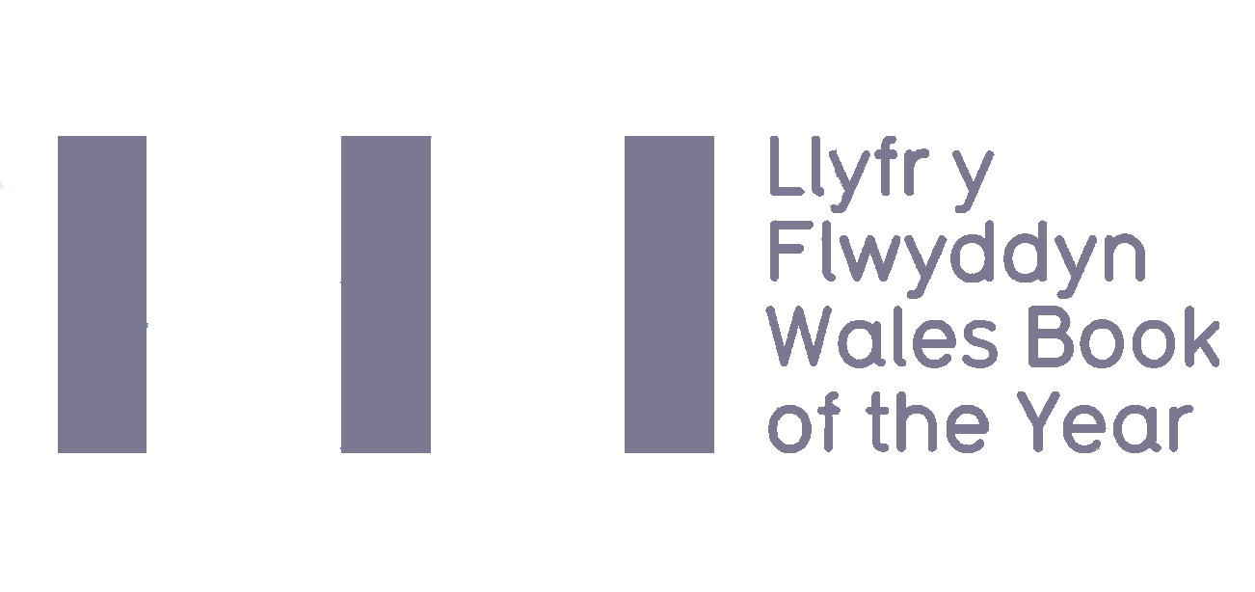
2021 Eligibility Criteria,
Terms & Conditions
and Entry Form
Deadline for submissions: Monday 7 December 2020*
*Books published between 1 – 31 December 2020 to be submitted by Friday 15 January 2021

Wales Book of the Year is an annual literary award celebrating the best Welsh works published within a calendar year in the fields of creative writing and literary criticism in both Welsh and English. Managed by Literature Wales, the awards are presented in four categories: Poetry, Fiction, Creative Non-Fiction, and Children & Young People.
There are twelve awards in total with a collective prize fund of £14,000. In both Welsh and English there are three category winners, one People’s Choice winner and one overall winner.
The Short List, which will comprise of three books in each category, will be announced in May, with the winners of Wales Book of the Year 2020 announced during the summer of 2020.

Eligibility Criteria
Please read and familiarise yourself with the eligibility criteria for Wales Book of the Year.
The title…
Must:
- Be the sole work of one writer (illustrations and introductions excluded)
- Be published for the first time (in either Welsh or English) in the calendar year preceding the award (1 January – 31 December 2020).
- The author must have been alive on the deadline for submissions – 1 December 2020.
- Be comprised substantially of work which has not been previously published in individually authored collections.
- Be a work of poetry, fiction, or creative non-fiction (see note below), OR intended for children & young people with a readership up to the age of 16.
- Work presented to the Poetry, Fiction, or Creative non-Fiction categories must be intended for an adult readership.
- Must be in print from the date the Short List is released until the winners are announced at the award ceremony.
- Be submitted to one category only. Work published bilingually can only be submitted for consideration in one language.
Plus at least one of the following:
- Be written in the Welsh language
- Be written in English by a Welsh-born writer, or someone who was schooled in Wales
- Be written in English by a writer who is currently resident in Wales
- Be of clear relevance to Wales and Welsh culture (see definition below)

The categories are defined as:
a. Poetry
A collection of new work by a single author and intended for adult readership.
b. Fiction
Eligible books submitted to this category must be new work by a single author which is intended for adult readership and can include all fiction genres.
c. Children & Young People
Submissions to the Children & Young People’s category must primarily consist of literary rather than pictorial content and intended for readership up to 16 years of age. Fiction, Poetry and literary non-fiction are all eligible and must meet the criteria detailed in a, b & d, except for readership age.

d. Creative non-fiction
Creative non-fiction is defined as prose writing which is either primarily creative in nature or discursively engages with other’s fiction, non-fiction or poetry. This includes works where the creativity of prose is central to the nature of the work. Types of books which COULD fall under such criterion include travel writing, graphic novels, autobiography/biography and social history.
Works of literary criticism are eligible for consideration if they are, or can be convincingly argued to be, relevant to Wales or Welsh culture (see definition below).

Definition of works which are of clear relevance to Wales and Welsh culture
Titles which discuss and/or add to themes which have a tradition of discourse in Welsh literary fields can, on occasions, be determined eligible for consideration despite the writer having no linguistic, residential or adolescent links with Wales.
Decisions on all eligibility issues will be at the discretion of Literature Wales. Their decision will be final.
If you are in any doubt about the eligibility of a book for Wales Book of the Year, please contact Literature Wales:
029 2047 2266 | LLYF-WBOTY@literaturewales.org

Terms and Conditions
To submit your books please send four copies of each title to the following address by Monday 7 December 2020:

Wales Book of the Year 2021
Literature Wales
Glyn Jones Centre
Wales Millennium Centre
Bute Place, Cardiff
CF10 5AL
Additionally, please send a copy of this form to LLYF-WBOTY@literaturewales.org along with the following items for each book submitted:
- a hi-res picture of the book cover (including any relevant credits)
- a hi-res picture of the author (including any relevant credits)
- a short description/blurb of the book
- a short biography of the author and contact details (email)
Please note: Literature Wales will confirm submission of titles only when all of the above items have been received.
- The six copied of books supplied by publishers are used for judging, administrative and publicity purposes.

- It is the publisher’s responsibility to indicate to which category each book is submitted. If the judges would like to consider the book for a different category, Literature Wales will contact the publisher/author for consent.

- As a condition of entry, publishers and writers agree to cooperate with Literature Wales and its partners to promote Wales Book of the Year.

- Shortlisted writers are expected to attend the Wales Book of the Year Award Ceremony, which may take place at Aberystwyth Arts Centre on 10 June 2021. Please note: If we are unable to host a live event alternative arrangement will be made and we will keep you updated of any changes to the timetable and arrangements. Unless in exceptional circumstances, Literature Wales reserves the right to withhold the monetary prizes if the winners do not attend the Award Ceremony.

- Shortlisted writers and winners will be required to be available for interviews following the announcements.

Entry Form

Publisher

Contact name
Email address
Phone number

English-language books
Title | Author | Date of publication | Category

Welsh-language books
Title | Author | Date of publication | Category

I confirm that:
- the above title(s) comply with the Wales Book of the Year Eligibility Criteria, and that I have read and agree with the Terms & Conditions.
- In addition, and for the purposes of promoting the Wales Books of the Year Awards, we agree to Literature Wales using the promotional material submitted (illustrations on book covers, book blurbs and author biographies and pictures).

Name:
Position:
Signed:
Date:

