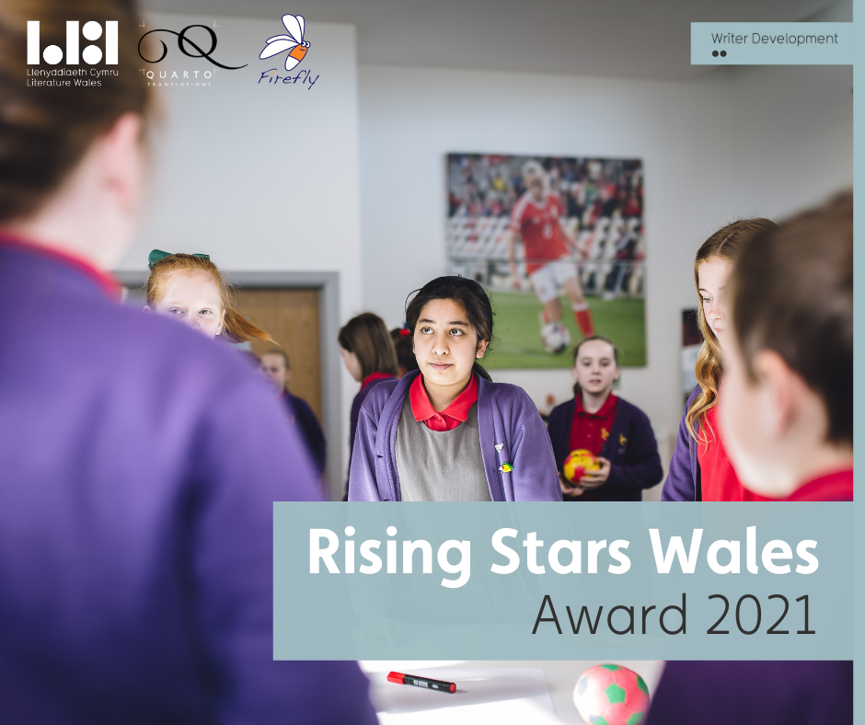
Call-out for submissions:
Literature Wales | Firefly Press
Rising Stars Wales Award 2021

The second round of an initiative to identify and nurture talented children’s poets from Black, Asian and Minority Ethnic backgrounds based in Wales, with the view to publish an anthology of their work.

Deadline: 5.00 pm, Tuesday 8 December 2020
The Overview
In November 2019, Literature Wales and Firefly Press collaborated on the Rising Stars Wales 2020 Award, a new initiative open to Black, Asian and Minority Ethnic children’s poets living in Wales. The award discovered new talent, provided opportunities, and spotlighted three talented emerging individuals. The poets continue to develop as writers and gain further opportunities as a result of the award. For example, 2020 Rising Star Alex Wharton signed a publishing deal with Firefly Press for his debut children’s poetry collection, Daydreams and Jellybeans, which is due to be published in spring 2021.

“I am deeply grateful accepting this award, I feel it recognizes my passion and dedication for writing Children’s Poetry. It has already opened up a terrific opportunity for me as the wonderful people at Firefly Press will be publishing my full collection of poems Daydreams and Jellybeans early next year. Poems are to be shared, they find the people who need them – and the award has enabled a wider platform for my words. It’s exciting and I am very thankful.”
Alex Wharton
Rising Star 2020

The Rising Stars Wales 2020 Award anticipated that the writers awarded through the call-out would be considered to produce work for the Rising Stars Wales Anthology. Following a successful application for financial support from the Books Council of Wales, Firefly Press will publish the anthology in early 2022. Literature Wales and Firefly Press are now looking for 5 additional talented poets to develop under this scheme.
This opportunity is open for early-career writers to develop their creative practice. Over the course of the year, the successful Rising Stars Wales 2021 applicants will receive a financial award, as well as a coaching session from the previous winner of the 2020 Award, Alex Wharton. In addition, the poets will have the opportunity to discover more about the publishing and literature sector from expert professionals at Firefly Press, as well as on-going support and advice from the team at Literature Wales.
The Rising Stars Wales Award 2021 is now open for submissions. There is no entry fee for this award. Full details can be found below.
Who can apply?
Poets or illustrators from a Black, Asian and Minority Ethnic background writing or illustrating work for children aged 7-11 years old. Applicants must be unpublished, based in Wales and be aged 18 or over.
What do you mean by an unpublished writer/poet?
We mean a poet or illustrator who has not accepted a traditional publishing deal. If your work has been featured in a magazine, or on an online blog, you are still eligible to apply. If you are unsure whether you are eligible, please get in touch.
What is on offer?
Up to 5 writers will be selected for the Rising Stars Wales 2021 Award and will receive:
- A cash prize of £100 each*
- Join the other successful applicants in a 2-hour coaching session with Alex Wharton, the previous winner of the Rising Stars Wales 2020 Award
- The possibility to have selected works published in the Rising Stars Wales Anthology
- A group ‘Industry Insight’ workshop with award-winning publisher Firefly Press
- A group training session focusing on writer development opportunities with Literature Wales staff
*With kind financial support from Quarto Translations

“Just as no language can cover the full range of human experience, so no writer has a monopoly on the way we see the world. Stories are a net, the wider we cast it, the more connections we make. This is why Quarto Translations is proud to sponsor the Rising Stars Wales Award.”
Robin Bennett
Founder and Managing Director, Quarto Translations

Guidelines
- The call-out for the Rising Stars Wales 2021 Award opens for entries on 8 October 2020 and closes at 5.00 pm, 8 December 2020. Any entries after this time will not be considered.
- You must identify as a writer from a Black, Asian or Minority Ethnic background.
- Applicants must be based in Wales and be aged 18 or over.
- We welcome submissions in Welsh and English, or in any other language (but you must provide a translation into English or Welsh, if original work is in another language).
- You may submit between 3-5 poems.
- Poems must not exceed 100 lines each.
- Poems submitted must be entirely your own work.
- Previous recipients of the Rising Stars Wales Award may not apply.
- Participation in the Rising Stars Wales 2021 Award grant Literature Wales and Firefly Press the unrestricted rights in perpetuity to publish and broadcast submitted poems in print, online, audio, performance and video. Winning poems may not be published elsewhere until September 2022.

How to apply
To apply, click here to complete the application form. You will be asked to include:
- 3 to 5 poems. Each poem should be collated into one .doc, .dox or .pdf document.
- A biography no longer than 200 words – containing a short summary about you and your interest in writing
- A current CV
- Equality and Diversity Monitoring Information
Applications can be submitted in either English or Welsh.
We anticipate that some of the writers identified through this call-out will be further commissioned to feature in the planned Rising Stars Wales Anthology.

Promotion, Marketing and Evaluation Requirements
After the selection process, successful writers will be required to provide:
- A 200-word short biography
- A recent high-resolution photo
- A series of quotes based on their experience
This will be used on Literature Wales’ and Firefly Press’ websites and social media channels.
Successful entrants will also be encouraged to write blogs, create videos and share information on their professional and artistic development on their own social media channels as the project develops.
The deadline for submissions is:
5.00 pm, Tuesday 8 December 2020
If you have any questions, or would like to discuss your entry before submitting, please contact Literature Wales:
post@literaturewales.org

About Us:
Literature Wales
Literature Wales is the national company for the development of literature. Committed to tackling under-representation in the literature sector, Literature Wales’ Strategic Plan for 2019-2022 outlines Representation and Equality as one of its main tactical priorities. Wales’ writers should comprise a range of ages, socioeconomic backgrounds, ethnicities, genders, regions and languages and not be typified by certain limited demographic profiles. This isn’t about excluding anyone. It is about creating equal and fair access to artistic innovation and professional development.

Firefly Press

Firefly Press is an award-winning independent children’s and YA publisher based in Cardiff and Aberystwyth. Set up in 2013, Firefly is the only dedicated children’s publisher in Wales, publishing quality fiction in all genres for 5-19 year olds. They aim to publish books by great authors and illustrators wherever they are from. Successes include The Clockwork Crow by Catherine Fisher, shortlisted for the Blue Peter Book Awards and winner of the Tir na N’og Children’s book Prize, and Aubrey and the Terrible Yoot by Horatio Clare, which won the Branford Boase first children’s novel award.

Quarto Translations

Quarto Translations has a dedicated team of mother-tongue translators who specialise in translation work for publishers. All book translations are proof-read by a second qualified translator and then proofed for a third time in-house before sending the final translation back to the client. Quarto Translations covers over 400 languages and provides a range of other services including typesetting, repro, print and distribution.

