Call-out for Expressions of Interest:
Opportunities for Writers, Filmmakers and Artists
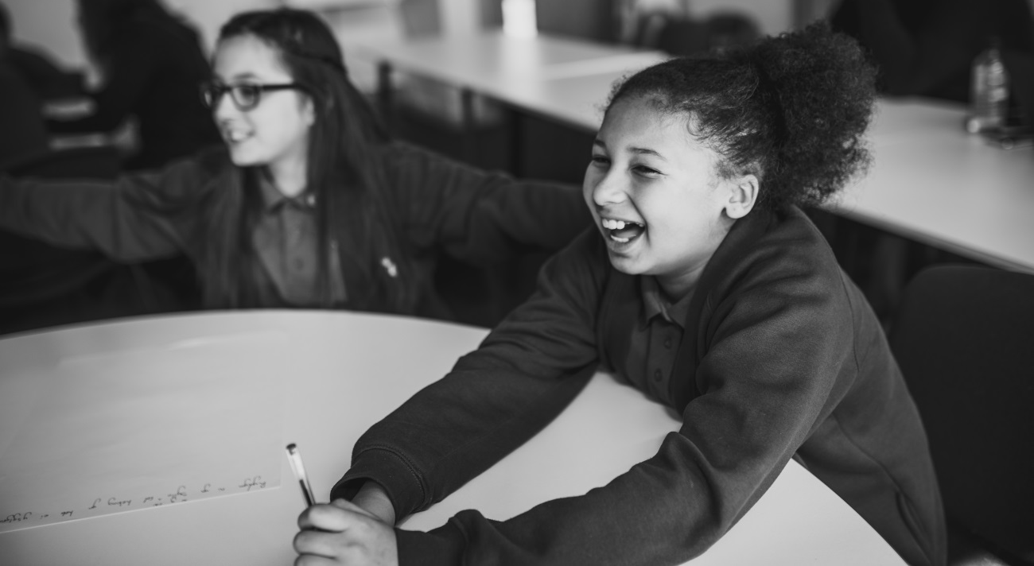
Participation in literature is one of Literature Wales’ main areas of work. We increase the accessibility and impact of creative writing for participants in Wales in order to inspire some of our most marginalised individuals and communities through active participation in literature.
We are currently inviting expressions of interest from writers, film-makers and illustrators to deliver three literature-based workshops in south Wales between February and March 2020. We have a long-standing partnership with many Local Authorities across Wales, and this is a continuation of specific projects in the Rhymney Valley, Cwmbran or Newport.
The focus and themes include: children & young people, intergenerational working, digital creativity, and cultural diversity.
Each project includes 3 workshops (around half day) at a fee of £150 per workshop with some additional relevant costs (agreed in advance). Please contact us for further information about the specific projects along with a budget breakdown: louise@literaturewales.org / 029 2047 2266.

In addition, we are inviting expressions of interest from creative professionals who are interested in delivering some of our other upcoming projects. This will contribute to the development of the creative and professional potential of a wider pool of writers.
Writers and artists based anywhere in Wales are welcome to apply. We will keep your application on file for 24 months, and may invite writers and creative practitioners to register an interest or provide a quote for the delivery of specific projects during that period.

Eligibility & Terms
The creative practitioner must:

- be willing and able to commit to deliver projects for the budget discussed and agreed with Literature Wales
- be able to work with older people and/or children aged 5-15
- be able to collaborate with other creative practitioners to produce a successful outcome
- have some experience in delivering participatory literature workshops have a current DBS check

How to submit your Expression of Interest

To express your interest in this opportunity, please provide the following:

- Complete the application form here
- Your CV, identifying relevant experiences and/or potential; and
- An Equality and Diversity Monitoring Form (available here).

Please send your CV and Equality and Diversity Monitoring Form to louise@literaturewales.org, with Artist call-out January-February 2020 and your name in the subject line.

Expressions of Interest should be sent to Literature Wales by:
12.00 noon on Thursday 6 February 2020

What happens next?

Literature Wales will select artists for the specific south Wales projects by 13 February 2020. Artists will be selected based on experience, suitability for the project and availability.
All expressions of interest will be kept on file for 24 months, and writers may be contacted during that time and invited to apply for or provide a quote for delivering literary participation projects relevant to their experience, interests and location.

Further Information About Literature Wales

Literature Wales is the national company for the development of literature. Our vision is a Wales where literature empowers, improves and brightens lives.

We are a registered charity, and work to inspire communities, develop writers and celebrate the literary culture of Wales. Literature Wales works in Welsh, English and bilingually across Wales. We have offices in Llanystumdwy and Cardiff. Our patron is Sir Philip Pullman.

We facilitate, fund and directly deliver a literary programme across Wales. All our activities are structured into three Activity Pillars. Concentrating on these three areas will help us to ensure that all of our work is clearly linked to our mission, and enable us to use our resources most effectively:

Participation – inspiring some of our most marginalised individuals and communities through active participation in literature.

Writer Development – developing the creative and professional potential of early career writers.

Wales’ Literary Culture – celebrating our contemporary writers and the literary heritage of Wales.

All of the pillars are inter-linked, and much of our work will flow from one to another. Projects will not be developed in isolation, but will complement and enhance each other, with clear progression and development during the three years.
Our Priorities

Based on our understanding of the power of literature to improve and transform lives, and the need to focus our activities where they will have greatest impact, we have identified three Tactical Priorities which will cross-cut all Activity Pillars. They are not types of activity but thematic priorities which will feature in everything we deliver, and in our partnership and facilitation work:

Representation & Equality – by ensuring representative inclusion throughout our activity and internal structures, we will provide platforms for, and encourage, under-represented literary voices; creating a national literary culture which represents contemporary Wales.

Health & Well-being – by supporting and advocating the various ways literature can contribute positively to the nation’s health and well-being, we will improve the lives of people in Wales.

Children & Young People – by increasing accessibility to, and conveying the joy of creative writing and reading, we will make a significant contribution to the well-being of the future generations of Wales.

