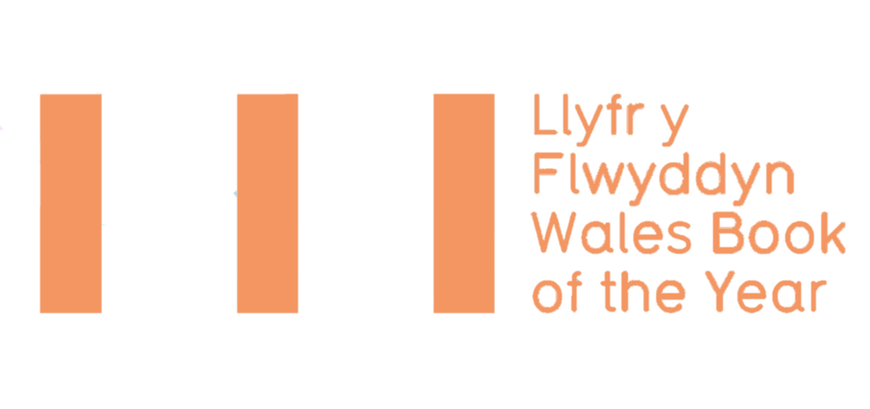
ELIGIBILITY CRITERIA
TERMS & CONDITIONS
ENTRY FORM 2019
Deadline for submissions:
Saturday 1 December 2018*
* Books published between 1 – 31 December 2018 to be submitted by 16 January 2019

Wales Book of the Year is an annual literary award celebrating the best Welsh works published within a calendar year in the fields of creative writing and literary criticism in both Welsh and English. Managed by Literature Wales, awards are presented in three categories: Poetry, Fiction, and Creative Non-Fiction.

There are ten awards in total with a collective prize fund of £12,000. In both Welsh and English there are three category winners, one People’s Choice winner and one overall winner.

The Short List, which will comprise of three books in each category, will be announced in May, with the winners of Wales Book of the Year 2019 announced at a ceremony held at Aberystwyth Arts Centre on 20 June 2019.

ELIGIBILITY CRITERIA
Please read and familiarise yourself with the eligibility criteria for Wales Book of the Year.
The title…
MUST:
- Be the sole work of one writer (illustrations and introductions excluded)
- Be published for the first time (in either Welsh or English) in the calendar year preceding the award (1 January – 31 December 2018)
- The author must have been alive on 1 December 2018 – the deadline for submissions
- Be comprised substantially of work which has not been previously published in individually authored collections
- Be a work of poetry, fiction or creative non-fiction (see note on page 3)
- Must be in print from the date the Short List is released until the winners are announced at the award ceremony.
- Be intended for an adult readership

PLUS AT LEAST ONE OF THE FOLLOWING:
- Be written in the Welsh language
- Be written in English by a Welsh-born writer, or someone who was schooled in Wales
- Be written in English by a writer who is currently resident in Wales
- Be of clear relevance to Wales and Welsh culture (see definition below)

THE FOLLOWING ARE NOT ELIGIBLE FOR CONSIDERATION:
- Work published within anthologies of multiple writers
- Translations (unless they are deemed to be of major significance to Welsh literature far beyond existing versions of the source material)
- Scripts

Note on literary non-fiction
Creative non-fiction is defined as prose writing which is either primarily creative in nature or discursively engages with other’s fiction, non-fiction or poetry. This includes all literary criticism, as well as other works where the creativity of prose is central to the nature of the work. Types of books which COULD fall under such criterion include travel writing, autobiography/biography and social history. Works of literary criticism are eligible for consideration if they are, or can be convincingly argued to be, relevant to Wales or Welsh culture.

Definition of works which are of clear relevance to Wales and Welsh culture
Titles which discuss and/or add to themes which have a tradition of discourse in Welsh literary fields can, on occasions, be determined eligible for consideration despite the writer having no linguistic, residential or adolescent links with Wales.

Titles with illustrations or images are judged on the quality of the writing alone and any award is made to the author alone. Literature Wales is the national company for the development of literature in Wales and as such is funded primarily to promote literary creativeness in the English and Welsh-language.

If you are in any doubt about the eligibility of a book for Wales Book of the Year, please contact Literature Wales: 029 2047 2266 | post@literaturewales.org

TERMS AND CONDITIONS
To submit your books please send four copies of each title to the following address by Saturday 1 December 2018:

Wales Book of the Year 2019
Literature Wales
Glyn Jones Centre
Wales Millennium Centre
Bute Place, Cardiff
CF10 5AL
Additionally, please send a copy of this form to post@literaturewales.org along with the following items for each book submitted:
- a hi-res picture of the book cover (including any relevant credits)
- a hi-res picture of the author (including any relevant credits)
- a short description/blurb of the book
- a short biography of the author and contact details (email and phone number)
Please note: Literature Wales will confirm submission of titles only when all of the above items have been received.
- A minimum of two additional copies of shortlisted books must be supplied by publishers for administrative and publicity purposes.

- It is the publisher’s responsibility to indicate to which category each book is submitted. If the judges would like to consider the book for a different category, Literature Wales will contact the publisher/author for consent.

- As a condition of entry, publishers and writers agree to cooperate with Literature Wales to promote Wales Book of the Year.

- Shortlisted writers are expected to attend the Wales Book of the Year Award Ceremony at Aberystwyth Arts Centre on 20 June 2019. Unless in exceptional circumstances, Literature Wales reserves the right to withhold the monetary prizes if the winners do not attend the Award Ceremony.

- Shortlisted writers and winners will be required to be available for interviews following the announcements.

ENTRY FORM

Publisher
Contact name
Email address
Phone number

English-language books
Title | Author | Date of publication | Category
Welsh-language books
Title | Author | Date of publication | Category
I confirm that the above title(s) comply with the Wales Book of the Year Eligibility Criteria, and that I have read and agree with the Terms & Conditions.

Name: Signed: Date:

