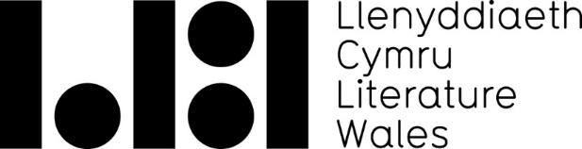
Writers on the Maes

Your Details
Name of Organisation*:
(*Please note that payment will be made to this organisation. We cannot make payment to an individual, a separate body or organisation other than the applicant)

Is your organisation a non-arts based charity or political party? Yes / No

If yes to above, please specify:

Is your organisation/event in receipt of funding from Arts Council of Wales? Yes / No

If yes to above, please specify:

Organiser Details

Organiser Name:

Email:

Telephone:

Address:

Website:

Event Details

Event Title:

Event Type: Live Event / Lecture / Workshop / Exhibition / Festival

Event Genre: Poetry / Fiction / Non-Fiction / Storytelling / Spoken Word

If Other, please specify:
Event Date:

Event Time*:
(*If applying for multiple events or series of workshops please include all dates and times below.)

Who is the event targeted at? Children and Young People / Adults

Ticket Prices (if applicable): £00.00

Writer Details

Writer Name:

Email:

Telephone:

Website:

Additional Writers:

Budget/Finance Details

Total fees paid to writer/s. Please list additional writers’ fees individually (*excluding expenses and all other costs): £00.00

Expected income from ticket sales, sponsorship or other sources (if applicable): £00.00

Total event cost: £00.00

Amount requested from Literature Wales: £00.00

Additional Information

Please inform us about any additional details which you think would strengthen your application:

Venue Details*
(*Only applicable to applications for strand 2)

If your project takes place away from the Eisteddfod site or at more than one location, please note the main location’s details here and any additional venues in the text box below.

Venue name:
Address 1:

Address 2:

City/Town;

Post Code:

Website:

Additional Venues:

Terms & Conditions
Fully completed application forms should be submitted well in advance, but must reach Literature Wales by 24 June. Late applications will be rejected.
Literature Wales aims to assess and process applications within 9 working days to the relevant deadline. If you do not hear from us within 10 days after the closing date, please contact us. Failing to do so may result in disappointment - it is the applicant's responsibility to ensure that the application reaches us in time. Literature Wales can only accept fully completed application forms. If crucial information is missing, your application may be returned to you and your application may be rejected due to the delay.
For the full terms and conditions, please see here.
Any Literature Wales funding offers are made to you on the basis that you accept these terms & conditions. By accepting any offers of funding from Literature Wales, you agree to these terms and conditions and are therefore bound to them.
Full Terms and Conditions are available on the Literature Wales Website.

